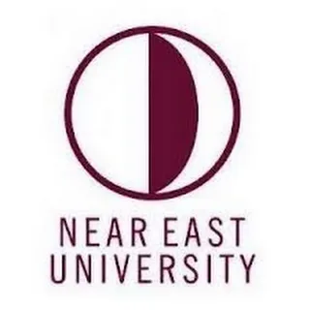
Faculty of Agriculture
Department of Food Engineering

Program Catalogue

1. FACULTY ABOUT 4
1.1. ESTABLISHMENT OF THE FACULTY 4
A) History and Academic Processes of the Faculty 4
B) Educational Policy and Academic Objectives 5
C) Physical and Academic Infrastructure 5
D) Accreditation and Quality Policy 5
1.2. Faculty Mission, Vision and Core Values 6
A) Mission 6
B) Vision 6
C) Core Values 6
1.3. Faculty Aims and Objectives 7
A) Aims and Goals Covering the Field of Education: 7
B) Aims and Objectives Covering the Research Area: 8
1.4. Faculty Organizational Chart 9
1.5. Faculty Administration 10
1.6. Academic Staff of the Faculty 11
A) Academic Structure and Main Disciplines 11
B) Distribution of Academic Staff and Human Resources Capacity 14
C) Academic Development and Quality Policy 15
1.7. Academic Programs Offered by the Faculty 17
2. GENERAL INFORMATION ABOUT THE PROGRAM 18
2.1. Brief History and Development of the Program 18
2.2. Type of Education Offered by the Program 18
2.3. Level of Study 18
2.4. Language of Instruction 19
2.5. Duration of the Program 19
2.6. Organizational Chart of the Program 19
2.7. Program Coordinator 20
2.8. Program Management and Academic Staff 20
3. PROGRAM MISSION AND VISION 21
3.1. Mission 21
3.2. Vision 21
4. PROGRAM’S CORE VALUES 21
5. PROGRAM ACTIVITY AREAS 22
6. PROGRAM PURPOSES AND OBJECTIVES 24
6.1. Purpose of the Program 24
6.2. Objectives of the Program 25
A) Purposes and Objectives Covering the Education Area 25
B) Purposes and Objectives Covering the Research Area 26
C) Objectives and Goals Covering Contribution to Society and Educational Services 26
7. PROGRAM QUALIFICATIONS 27
7.1. Program Qualifications 27
7.2. The Relationship Between Program Qualifications and the Turkish Higher Education Qualifications Framework 29
7.3. The Relationship Between Courses and Program Qualifications 30
8. COURSE LIST 31
8.1. Distribution Tables of Semester and Elective Courses in the Program 31
8.2. Common Compulsory Courses Offered University-Wide 32
8.3. Course Syllabus 32
9. PRINCIPLES OF PROGRAM ASSESSMENT AND EVALUATION 33
9.2. Letter Grade Conversion Table 33
10. STUDENT ADMISSION AND REGISTRATION REQUIREMENTS 36
11 Horizontal and Vertical Transfer Opportunities 37
11.1. Horizontal Transfer Opportunities 37
11.2. VERTICAL TRANSFER OPPORTUNITIES 38
12. RECOGNITION AND CREDIT TRANSFER OF PREVIOUS LEARNING 38
13. INTERNATIONAL PROGRAMS AND EXCHANGE OPPORTUNITIES 39
14. ACCREDITATION AND QUALITY ASSURANCE OF THE PROGRAM 40
14.1. Quality Policy 40
14.2. Accreditation Process of the Program 41
14.3. Quality of Education 42
14.4. Research and Development Activities 42
14.5. Continuous Improvement Process 43
15. GRADUATION REQUIREMENTS AND AWARDED DEGREE 43
15.1. Graduation Requirements 43
15.2. Awarded Degree 44
16. DIPLOMA SUPPLEMENT 44
17. EMPLOYMENT OPPORTUNITIES FOR GRADUATES AND ACCESS TO GRADUATE PROGRAMS 44
17.1. Employment Opportunities for Graduates 44
17.2. Access to Graduate Programs 45
18. ADDITIONAL INFORMATION 45

1. FACULTY ABOUT
1.1. ESTABLISHMENT OF THE FACULTY
Near East University Faculty of Agriculture was established in 2021. It has three separate departments. These departments are Landscape Architecture, Food Engineering and Animal Science. The duration of education in all three departments is four years.
Faculty of Agriculture, with its qualified and expert academic staff, aims to train individuals, who possess professional agricultural, food and environmental knowledge, subject matter expertise, and general culture; that are inquisitive, questioning, and proficient in technology, committed to ethical values, and equipped with strong communication skills.
The Faculty of Agriculture considers contributing to the overall quality of the education system by nurturing agricultural enginners, food engineers, landscape architects who are sensitive to societal needs, are open to collaboration, and capable of creative and critical thinking, thereby promoting quality education in the institutions where its graduates serve.

A) History and Academic Processes of the Faculty
Near East University Faculty of Agriculture was established in 2021 and started its education activities in line with the decision of the Ministry of National Education and Culture of the Turkish Republic of Northern Cyprus and the Higher Education Supervision and Accreditation Board (YÖDAK) (Decision Number - YOD 0.00- 223/02-21/E. 542).
After the establishment of the faculty, the Departments of Landscape Architecture and Food Engineering, which were previously providing education under other faculties, were deemed appropriate to be transferred to the Faculty of Agriculture by YÖK with the decision numbered E- 75850160-301.01.01-11123 on 16.02.2022.
The Department of Landscape Architecture has programs offering English education at undergraduate and graduate levels. There are programs offering undergraduate education in English and Turkish in the Department of Food Engineering. The undergraduate English program of the Department of Animal Science received permission to start education on October 5, 2023 (YÖDAK Decision number: 2023/ 45-9). There is a program in the Department of Animal Science that offers undergraduate education in English.

B) Educational Policy and Academic Objectives
Faculty of adopts a contemporary educational approach in line with a progressive educational philosophy, implementing a student-centered teaching model that encourages interdisciplinary collaboration. The educational programs are structured in accordance with international standards and successfully undergo accreditation processes within the scope of quality assurance. Graduates of the faculty contribute to the professional and academic fields as competent, creative individuals with strong ethical values. Faculty members contribute to science through their scientific research, R&D activities, and community projects, aiming to lead societal development.

C) Physical and Academic Infrastructure
Administrative Offices: The Dean's Office of the Faculty of Agriculture is located on the fourth floor of the Faculty of Pharmacy building. Faculty
Faculty of Agriculture offers students a variety of social and academic study spaces through classrooms designed in line with a modern educational approach, technologically equipped laboratories, and digital learning platforms.
Within the framework of cooperation between the Ministry of Natural Resources and Agriculture, private Landscape companies from Antalya – Turkey, private food companies and animal production companies the faculty provides students with internship and practical training opportunities. This support enables students to gain professional experience prior to graduation.

D) Accreditation and Quality Policy
Faculty of Agriculture adopts national and international quality standards in its educational and research processes; accordingly, it aims to enhance the quality of education through a continuous improvement approach. The faculty actively participates in national and international accreditation processes, regularly reviewing and developing its educational programs. The programs are structured considering professional ethics, safety standards, and current requirements, aiming to equip students with competent and well-prepared professional skills.

1.2. Faculty Mission, Vision and Core Values
A) Mission
As with all the studies undertaken and carried out by our university throughout the island, our Faculty of Agriculture aims to serve our country and humanity by creating a contemporary learning and progress environment by contributing to the development of new knowledge, technology and products, especially within the framework of sustainability and ethical principles in the agricultural field. In this context, our faculty was established with the aim of training landscape architects, food engineers and zootechnicians who are innovative, highly aware and capable of working interdisciplinary.

B) Vision
Our aim is to be a student-oriented faculty that contributes to economic, social, community and cultural life at both national and international levels, uses technology effectively, keeps sustainability at its core in all its dimensions, and is a quality and pioneer in science.

C) Core Values
Student Oriented: To provide a participatory and supportive educational environment that centers on students' academic, social and professional development.
Scientific and Productivity: Encouraging thinking skills based on scientific methods; Adopting a creative and productive approach in research, design and application processes.
Sustainability: Based on sustainable design principles that consider the protection of natural resources, environmental sensitivity and ecological balance.
Accessibility and Equity in Education: Creating an inclusive, diverse, and accessible learning environment that provides equal opportunities for all.
Commitment to Ethical Principles: Aiming to cultivate individuals who respect academic and professional ethical values and are responsible towards society and the environment.
Collaboration and Participation: Adopting an approach that values interdisciplinary studies, public-private sector collaborations, and stakeholder engagement.
Innovation and Continuous Improvement: Developing a vision that adapts to changing global conditions, monitors digitalization and new technologies, and encourages continuous learning.
These core values define the department not only as an academic training center but also as an institution that trains socially responsible, environmentally conscious, and innovative landscape architects, food engineers, and zootechnical agricultural engineers.

1.3. Faculty Aims and Objectives
A) Aims and Goals Covering the Field of Education:
Aim 1: To train graduates who integrate theoretical knowledge with practical skills in the fields of Landscape Architecture, Food Engineering, and Animal Sciences.
Goal 1.1: To develop workshop, fieldwork, and project-based courses where students can apply their subject knowledge in the field.
Goal 1.2: To create accessible and digitally supported learning environments equipped with current technologies.
Goal 1.3: To enable students to acquire professional competence at national and international levels.

Aim 2: To train critical-thinking, creative, and sustainability-oriented designers, zootechnical agricultural engineers and food engineers.
Goal 2.1: To create course content that develops problem-solving, analysis, and critical thinking skills in design processes, food engineering and animal sciences
Goal 2.2: To encourage students to produce designs that is highly environmentally conscious and embraces sustainability principles.
Goal 2.3: To train innovative and entrepreneurial individuals who are open to interdisciplinary studies.

B) Aims and Objectives Covering the Research Area:
Aim 1: To produce scientific knowledge and increase research capacity in the field of landscape architecture, food engineering and animal sciences
Goal 1.1: To create teaching and project environments which encourage students' participation in research processes.
Goal 1.2: To improve the infrastructure and incentive opportunities for academic staff to conduct research projects.
Goal 1.3: To increase the department's visibility in national and international scientific events.
Goal 1.4: To produce scientific studies focused on sustainable, nature-based solutions.

Aim 2: To conduct research that will produce solutions to environmental, social, and cultural problems on a local and global scale.
Goal 2.1: To develop interdisciplinary projects on urban open spaces, rural landscapes, climate change and ecological planning, rural agriculture, food health and safety, food packaging, animal husbandry, animal nutrition, animal welfare and hygiene.
Goal 2.2: To introduce students to the role of a researcher by encouraging field-based, applied research.
Goal 2.3: To increase the quantity and quality of academic publication production.

1.4. Faculty Organizational Chart

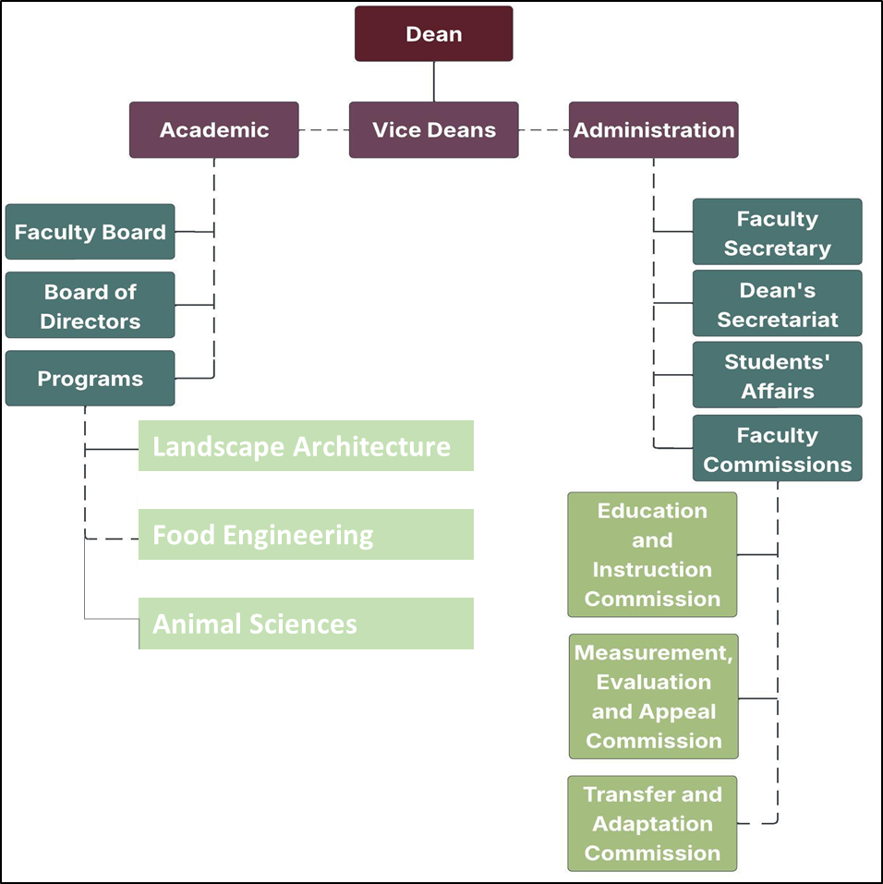
Figure 1. Organizational Chart

1.5. Faculty Administration
There are five faculty members on the faculty board of the Faculty of Agriculture. The titles, names and duties of these members are listed in Figure 2 below.

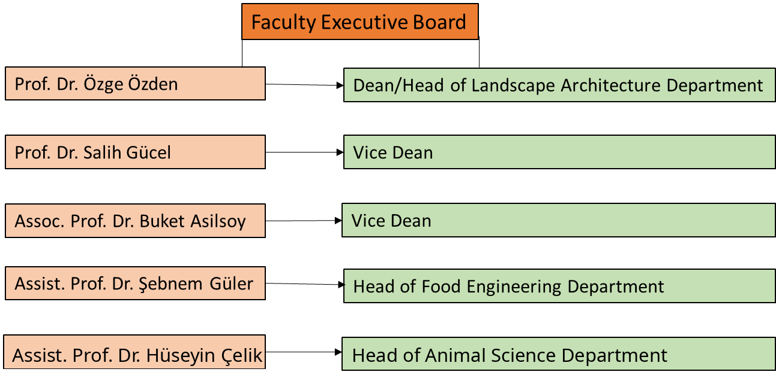

Figure 2: Faculty Executive Board

There are also five faculty members on the faculty board of the Faculty of Agriculture. The titles, names and duties of these members are listed in Figure 3 below.

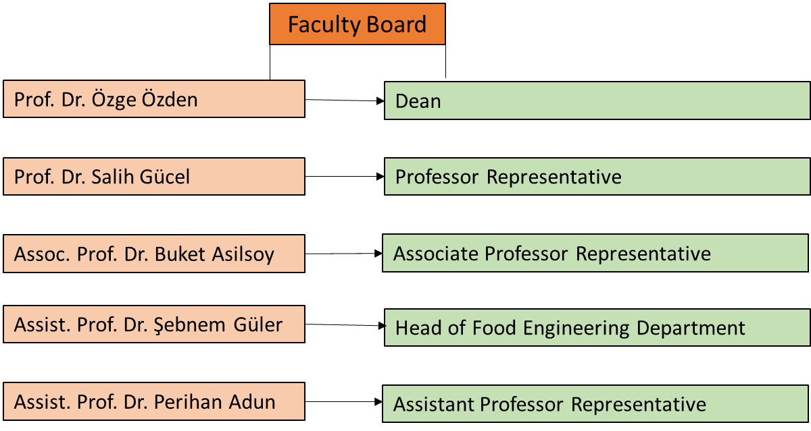

Figure 3: Faculty Board
1.6. Academic Staff of the Faculty
A) Academic Structure and Main Disciplines

The Faculty of Agriculture comprises three separate departments: Landscape Architecture (English), Food Engineering (Turkish and English), and Animal Science (English) (Figure 4). The duration of study in all three departments is four years. Tables 1-5 show the departments within the faculty.

Figure 4. Chart showing 3 different Departments

Table 1. List of Full-Time Faculty Members Teaching in Landscape Architecture Undergraduate (English Program)
 | Landscape Arhitecture BSc Programme
 | 2025-2026 FALL | 2025-2026 SPRING | 2026-2027 FALL
Muhammed Adeel | √ | √ | √
Derviş Ali Özersoy | √ | √ | √
Dr. Aysel Mirkasımova | √ | √ | √
Assist. Prof. Dr. Serhat Usanmaz | √ | - | √

Table 2. List of Part-Time Instructors Teaching in Landscape Architecture Undergraduate (English Program)
 | Landscape Arhitecture BSc Programme
 | 2025-2026 FALL | 2025-2026 SPRING | 2026-2027 FALL
Muhammed Adeel | √ | √ | √
Derviş Ali Özersoy | √ | √ | √
Dr. Aysel Mirkasımova | √ | √ | √
Assist. Prof. Dr. Serhat Usanmaz | √ | - | √

Table 3. List of Full-Time Faculty Members Teaching in Food Engineering Undergraduate Programs (Turkish and English Programs)
 | TURKISH PROGRAMME |  |  | ENGLISH PROGRAMME
 | 2025-2026 FALL | 2025-2026 SPRING | 2026-2027 FALL | 2025-2026 FALL | 2025-2026 SPRING | 2026-2027 FALL
Assist Prof. Dr. Perihan Adun | √ | √ | √ | √ | √ | √
Assist. Dr. Şebnem Güler | √ | √ | √ | √ | √ | √
Dr. Mehmet Karagözlü | √ | √ | √ | √ | √ | √

Table 4. List of Part-Time Lecturers Teaching in Food Undergraduate Programs (Turkish and English Programs)
 | TURKISH PROGRAMME |  |  | ENGLISH PROGRAMME
 | 2025-2026 FALL | 2025-2026 SPRING | 2026-2027 FALL | 2025-2026 FALL | 2025-2026 SPRING | 2026-2027 FALL
Prof. Dr. Nevzat Artık | √ | √ | √ | √ | √ | √

Table 5. List of Full-Time Faculty Members Teaching in Animal Sciences Undergraduate Programme (English Programme)
 | ENGLISH PROGRAMME
 | 2025-2026 FALL | 2025-2026 SPRING | 2026-2027 FALL
Assist. Prof. Dr. Hüseyin Çelik | √ | √ | √
Assoc. Prof. Dr. Valiollah Palangi | - | - | √

B) Distribution of Academic Staff and Human Resources Capacity
Faculty of Agriculture consist of total number of 9 Full time academics. Table 6 is showing distribution of academic staff by Programs.

Table 6. Distribution of Full – Time Academic Staff by Programs
 | Faculty | Department | Academics
1 | Faculty of Agriculture | Landscape Architecture | Prof. Dr. Özge Özden
2 | Faculty of Agriculture | Landscape Architecture | Prof. Dr. Salih Gücel
3 | Faculty of Agriculture | Landscape Architecture | Assoc. Prof. Dr. Buket Asilsoy
4 | Faculty of Agriculture | Landscape Architecture | Dr. Sinem Yıldırım
5 | Faculty of Agriculture | Food Engineering | Assist. Prof. Dr. Perihan Adun
6 | Faculty of Agriculture | Food Engineering | Assist. Prof. Dr. Şebnem Güler
7 | Faculty of Agriculture | Food Engineering | Dr. Mehmet Karagözlü
8 | Faculty of Agriculture | Animal Sciences | Assist. Prof. Dr. Hüseyin Çelik
9 | Faculty of Agriculture | Animal Sciences | Assoc. Prof. Dr. Valiollah Palangi

C) Academic Development and Quality Policy
Near East University Faculty of Agriculture consists of a total of 3 main disciplines, including Landscape Architecture, Food Engineering and Animal Sciences. The faculty is recognized for its expert and experienced academic staff. As of the 2026–2027 academic year, the faculty includes 2 professors, 2 associate professors, 3 assistant professors, and 2 PhD holders, totaling 9 full-time academic personnel. The academic staff contributes to both undergraduate and postgraduate education, and, with their research-oriented profiles, they actively engage in scientific studies. In addition, to support their professional development, they participate in a variety of training and development programs and play active roles in national and international projects, thereby advancing their individual academic careers and enhancing the university’s global recognition.
Detailed information regarding the areas of expertise of the academic staff working full-time at the faculty is given in the table below.

Table 7. Academic Staff Information Table
 | Name-Surname | Area of ​​Expertise |  |  |  | English Proficiency
 |  | BSC | Master | PhD | PhD Obtained University Name
1 | Prof. Dr. Özge Özden | Agriculture Engineer Plant Protection | Agriculture Engineer Plant Protection | Biological Sciences | Exeter University | IELTS 7
2 | Prof. Dr. Salih Gücel | Biology | Biology  Botany | Biology  Botany | Ege University | IELTS 8
3 | Assoc. Prof. Dr. Buket Asilsoy | Landscape Architecture | Landscape Planning | Architecture | Eastern Mediterranean University | EPTT (B2)  YÖKDİL: 90
4 | Dr. Sinem Yıldırım | Landscape Architecture | Landscape Architecture | Architecture | Near East University | -
5 | Assistant Prof. Dr. Perihan Adun | Agriculture Engineer Food Science and Technology | Agriculture Engineer Food Science and Technology | Food Engineering | Ankara University | NPT (B)
6 | Assistant Prof. Dr. Şebnem Güler | Food Engineering | Food Engineering | Food Engineering | Çukurova  University | EYDS (61.25)  YÖKDİL (80)
7 | Dr. Mehmet Karagözlü | Food Engineering | Food Engineering | Nutrition and Dietetics (continue) | - | YÖKDİL (83,5)
8 | Assist. Prof. Dr. Hüseyin Çelik | Business | Economy and Agricultural Economics | Agricultural Economics | Çukurova University | YÖKDİL (77,5)
9 | Assoc. Prof. Dr. Valiollah Palangi | Agriculture Engineer Animal Production | Animal Nutrition | Animal Nutrition | Atatürk University | NPT (C)

1.7. Academic Programs Offered by the Faculty
The Faculty of Agriculture offers a wide range of academic programs at undergraduate, master's, and doctoral levels, providing broad opportunities for students who aim to gain in-depth knowledge in the field of agriculture. Each program enables students to specialize in their chosen field and contribute to the advancement of the educational system. The programs offered within the faculty are listed below:

Undergraduate Programs
- Department of Landscape Architecture
- Department of Food Engineering
- Department of Animal Sciences

Master’s Programs (Thesis and Non-Thesis)
- Department of Landscape Architecture

2. GENERAL INFORMATION ABOUT THE PROGRAM
2.1. Brief History and Development of the Program
Food Engineering English program commenced its educational process with the decision numbered 33/2006 by the Higher Education Planning, Supervision, Accreditation and Coordination Board (YÖDAK) and the decision numbered B.30.0.EÖB.000.00.03-06.05 dated 17.06.2009 by the Council of Higher Education (YÖK); the Turkish program commenced with the decision numbered 33/2006-13 by the Higher Education Planning, Supervision, Accreditation and Coordination Board (YÖDAK). The Food Engineering Department aims to train successful engineers who can adapt to technological developments and generate new knowledge, apply fundamental engineering knowledge to food engineering, possess a scientific understanding, are dedicated to their duties, and respect ethical values.

2.2. Type of Education Offered by the Program
The Department of Food Engineering offers formal education. Within this scope, courses are conducted face-to-face, online, and through hybrid methods, combining both theoretical and practical components.

2.3. Level of Study
The Department of Food Engineering offers a 4-year undergraduate program comprising 240 ECTS credits. The program meets the qualification requirements of Level 6 within the Turkish Higher Education Qualifications Framework (TYYÇ). In line with the European Qualifications Framework for Higher Education (QF-EHEA), it corresponds to the First Cycle (Bachelor’s Level). The curriculum has been meticulously designed to fulfill both the ECTS credit requirements and the expected learning outcomes defined at this qualification level.

2.4. Language of Instruction
The language of instruction for the Department of Food Engineering is English.

2.5. Duration of the Program
The duration of the Food Engineering program is 4 years (8 semesters). The department operates two semesters per academic year, Fall and Spring, comprising a total of 28 weeks.

2.6. Organizational Chart of the Program

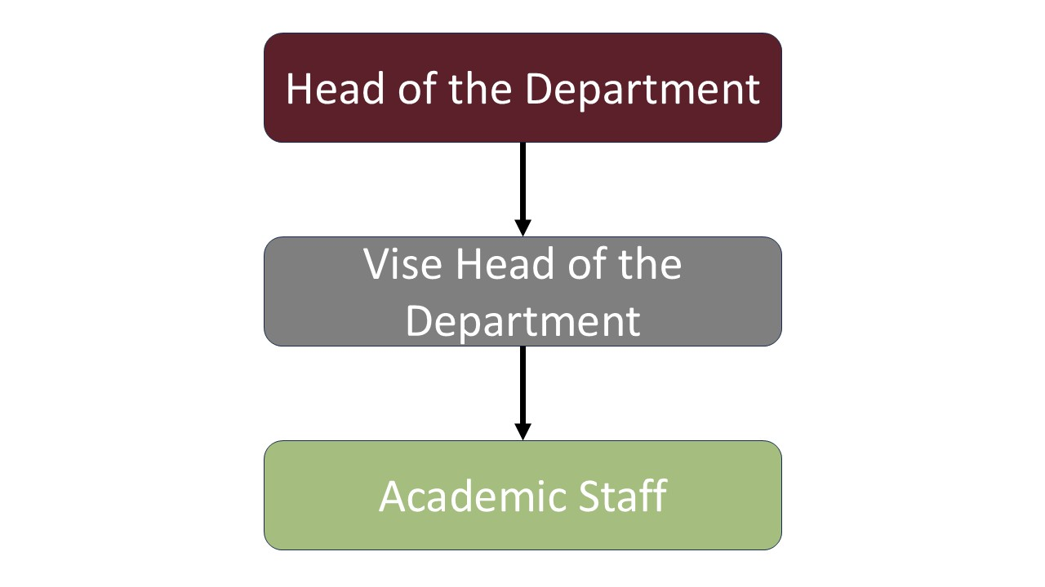
Figure 5. Organizational chart of the program

2.7. Program Coordinator

Program Coordinator:
Assist. Prof. Dr. Şebnem GÜLER
Head of the Department
sebnem.guler@neu.edu.tr

2.8. Program Management and Academic Staff

The Department of Food Enginnering within Faculty of Agriculture aims to produce successful engineers who can adapt to technological advancements and generate new knowledge, apply fundamental engineering skills to food engineering, possess a scientific understanding, are dedicated to their duties, and respect ethical values. The Food Engineering Department contributes to both theoretical and applied education with its expert academic staff. As of 2026, the Department of Animal Science has a total of 2 full-time academic staff members, consisting of 1 Associate Professor and 1 Assistant Professor. The academic staff contributes to the field through undergraduate and graduate-level education, thesis supervision, and scientific research. Faculty members play an active role in projects supporting professional development, in-service training, and academic collaborations.

Academic Staff
Prof. Dr. Nevzat Artık | Academic Staff
Yrd. Doç. Dr. Perihan Adun | Academic Staff
Yrd. Doç. Dr. Şebnem Güler | Head of the Department
Dr. Mehmet Karagözlü | Vise Head of the Department

3. PROGRAM MISSION AND VISION
3.1. Mission
The mission of the Department of Food Engineering is to train successful engineers who can adapt to the technological advancements of the 21st century, generate new knowledge, apply fundamental engineering knowledge to food engineering, possess a scientific understanding, are dedicated to their duties, and respect ethical values. Graduates of our department will be equipped with the highest level of knowledge in food production, distribution, marketing, and quality control, as well as in the design, development, and use of tools and machinery used in the food industry.
3.2. Vision
The vision of the Department of Food Engineering is to be a leading educational and research institution that provides its students with high-quality, internationally recognized undergraduate and postgraduate education; that explores new fields of science, conducts high-quality scientific research, and cultivates innovative and exemplary individuals; and that offers solutions to the problems of manufacturing and industrial organizations, contributing its expertise for the benefit of society.
4. PROGRAM’S CORE VALUES

- Commitment to Atatürk's Principles and Reforms
- Participatory and Democratic Approach
- Respect for Human Rights
- Environmental Awareness
- Critical and Creative Thinking Ability
- Productivity in Scientific Research
- Sustainability Awareness
- Effectiveness in Social Life
- Openness to Interdisciplinary Cooperation
- Commitment to Ethical Values
- Raising Responsible and Active Individuals
- Local and Global Awareness
5. PROGRAM ACTIVITY AREAS
Educational Activities
The Food Engineering Program is structured to enable students to acquire fundamental engineering knowledge, professional skills, and ethical responsibility in the fields of food production, processing, preservation, quality, and safety. The program aims to train graduates to become food engineers who can think analytically, have problem-solving skills, can work interdisciplinarily, and possess a lifelong learning awareness in the field of food science and technology.
The curriculum begins with mathematics, basic sciences, and engineering sciences, and deepens with specialized courses in food chemistry, food microbiology, food engineering processes, food analysis, process design, quality control, and food technology. Theoretical courses are supported by laboratory applications, project-based studies, internships, and graduation design courses to develop students' practical skills. The program utilizes student-centered teaching approaches, problem-solving-based learning, laboratory experiments, group work, and project presentations as active learning methods. Assessment and evaluation processes include written exams, laboratory reports, project performances, presentations, and application-based assessment tools. Academic counseling and guidance services are provided to support students' academic and professional development; learning outcomes are regularly monitored and improved.

Research and Development Activities
The Food Engineering Program aims to conduct scientific studies in areas such as food safety, food quality control, new product development, food processing technologies, sustainable production, functional foods, and food loss reduction within the scope of research and development activities. National and international research projects, scientific publications, and laboratory-based studies conducted by faculty members strengthen the academic quality of the program and ensure that current scientific developments are reflected in education. Undergraduate students are actively involved in research processes through laboratory courses, term projects, summer internships, and graduation design studies. These research and development activities improve students' scientific thinking, data analysis, experiment design, and reporting skills; and also contribute to their development as individuals who can produce solutions to current problems in the professional field. Due to the research-based learning approach, students' academic development is supported, and their orientation towards postgraduate education is encouraged.

Professional Development and Continuing Education Activities
Professional development and continuing education activities in the Food Engineering Program; The program is supported by seminars, technical trips, industry collaborations, certificate programs, and workshops aimed at keeping the professional knowledge and competencies of students and faculty up-to-date. Innovations in the food industry, quality and safety standards, regulatory practices, and new technologies form the main focus of these activities. Students gain professional awareness through interviews with industry representatives, factory visits, and internships; their preparation for professional life is supported. The continuous development of the program is ensured by encouraging the participation of faculty members in scientific meetings, publication production, and collaborations with professional organizations. The professional development activities carried out within this scope increase students' professional self-confidence, improve their communication and teamwork skills, and positively contribute to their employability after graduation.

Community Contribution and Service Activities
The Food Engineering Program conducts community-oriented activities within the framework of social contribution and service activities, focusing on raising awareness of food safety, healthy eating, reducing food waste, and sustainable production. Faculty members and students interact with the community through social responsibility projects, training seminars, and public benefit events. Through collaborations with local producers, public institutions, and non-governmental organizations, the aim is to transform food engineering knowledge into social benefit. These activities contribute to students' development of social responsibility, ethical sensitivity, and professional awareness. Through community service activities, students are trained not only as individuals with technical knowledge but also as responsible food engineers who are sensitive to public health and sustainable development.

6. PROGRAM PURPOSES AND OBJECTIVES
6.1. Purpose of the Program
The purposes of the Food Engineering Program are stated below:
Purpose 1: To train graduates with strong fundamental engineering knowledge in the field of food engineering.
Purpose 2: To provide practical competence in the areas of food production, processing, quality, and safety.
Purpose 3: To train engineers with advanced problem-solving, design, and process development skills.
Purpose 4: To train engineers capable of conducting scientific research and innovation.
Purpose 5: To train engineers sensitive to ethical values, social responsibility, and sustainability.
Purpose 6: To train engineers with a lifelong learning mindset and who continuously improve themselves.
6.2. Objectives of the Program

A) Purposes and Objectives Covering the Education Area

Purpose 1: To train graduates with strong fundamental engineering knowledge in the field of food engineering.
- Objective 1.1: To impart knowledge in mathematics, science, and basic engineering.
- Objective 1.2: To teach theoretical knowledge related to food science and technology.
- Objective 1.3: To apply fundamental engineering knowledge to food engineering problems.

Purpose 2: To develop practical competence in food production, processing, quality, and safety.
- Objective 2.1: To develop the ability to analyze food production and processing processes.
- Objective 2.2: To teach food safety, hygiene, and sanitation principles.
- Objective 2.3: To implement quality control and quality assurance systems.
- Objective 2.4: To provide knowledge about food legislation and standards.

Purpose 3: To train engineers with advanced problem-solving, design, and process development skills.
- Objective 3.1: To develop the ability to identify and analyze food engineering problems.
- Objective 3.2: To develop engineering solutions for food processes and unit operations.
- Objective 3.3: To acquire the competence to design processes, products, and systems.
- Objective 3.4: To effectively utilize modern engineering tools and technologies.

B) Purposes and Objectives Covering the Research Area
Purpose 4: To train engineers who can conduct scientific research and be innovative.
- Objective 4.1: To provide knowledge about scientific research methods and techniques.
- Objective 4.2: To develop research skills through experiments, projects, and graduation projects.
- Objective 4.3: To improve scientific literature review and data analysis skills.
- Objective 4.4: To develop the ability to report and present research results.

C) Objectives and Goals Covering Contribution to Society and Educational Services
Purpose 5: To train engineers who are sensitive to ethical values, social responsibility, and sustainability.
- Objective 5.1: To instill awareness of acting in accordance with professional ethical principles.
- Objective 5.2: To evaluate the social and environmental impacts of food engineering applications.
- Objective 5.3: To develop awareness of sustainable production and resource use.

Purpose 6: To train engineers who are aware of lifelong learning and constantly improve themselves.
- Objective 6.1: To instill the habit of following scientific and technological developments.
- Objective 6.2: To encourage participation in professional development and continuing education activities.
- Objective 6.3: To guide towards postgraduate education and continuing learning.

7. PROGRAM QUALIFICATIONS
7.1. Program Qualifications
KNOWLEDGE – Theoretical and Factual Learning Outcomes
PQ1. Has a sound understanding of theoretical and applied knowledge in mathematics, natural sciences, basic engineering principles, and food science; effectively uses this knowledge in food engineering applications and applies it to problem-solving processes.
PQ2. Possesses knowledge of food quality and safety principles, hygiene and sanitation practices, quality assurance and control systems, as well as relevant standards and legislation; applies these systems and contributes to their improvement.
PQ3. Has practical competence in industrial processes such as food production lines, process control, unit operations, occupational health and safety, quality management, and production planning, and optimizes these processes.

SKILLS – Cognitive and Practical Learning Outcomes
PQ4. Identifies, analyzes, and solves complex problems encountered in food engineering applications by selecting and applying appropriate modeling, evaluation, and solution methods.
PQ5. Designs processes, products, or systems by considering realistic technical, environmental, economic, and sustainability constraints; incorporates scientific and technological advancements into design decisions.
PQ6. Selects and effectively uses modern tools, analytical techniques, laboratory equipment, and computer technologies employed in food engineering applications, and evaluates their limitations.
PQ7. Conducts scientific literature reviews; designs and carries out experiments and projects; collects data and analyzes results using statistical methods to generate scientifically grounded outcomes; applies and contributes to risk management, innovation, and entrepreneurship processes.

COMPETENCIES – Learning Outcomes for Autonomy and Responsibility
PQ8. Effectively works independently or as a member of intra- and interdisciplinary teams; assumes leadership when necessary and ensures task allocation and coordination in line with project objectives.
PQ9. Analyzes the impacts of food engineering activities in terms of ethics, economics, social life, public health, environmental protection, and sustainability, and acts with a strong sense of professional responsibility.

COMPETENCIES – Learning Competence Learning Outcomes
PQ10. Develops learning strategies for professional development; follows scientific and technological innovations and continuously updates professional knowledge.

COMPETENCIES – Communication and Social Competence Learning Outcomes
PQ11. Communicates effectively in written and oral forms in Turkish and at least one foreign language; prepares professional reports, delivers presentations, and follows developments in the field.

COMPETENCIES – Field-Specific Competence Learning Outcomes
PQ12. Acts in accordance with professional ethical principles; is aware of scientific and professional responsibilities and applies ethical decision-making processes.
PQ13. Evaluates food production processes in line with sustainability principles; optimizes resource utilization and develops and implements engineering approaches that consider environmental protection and social benefit.

7.2. The Relationship Between Program Qualifications and the Turkish Higher Education Qualifications Framework
The Turkish Higher Education Qualifications Framework (THEQF) is a framework established to ensure the quality assurance of higher education programs in Turkey and to define national-level qualifications. This framework is designed to be compatible with the European Qualifications Framework (EQF). It covers the levels of undergraduate, graduate, and doctoral education.
A) Structure of THEQF
The Food Engineering program is at TYYÇ Level 6 bachelor's degree (EQF-LLL: Level 6, QF-EHEA: First Cycle). The Food Engineering program is aligned with the TYYÇ 52-54 – Engineering, Production and Processing Basic Field Bachelor's Degree Qualifications.

B) Preparing the Matrix of the Relationship Between Program Qualifications and THEQF
A matrix showing the relationship between program qualifications and the THEQF is included in the appendix.
Drive Link:
https://ziraat.neu.edu.tr/wp-content/uploads/sites/153/2026/02/05/TYYC-ile-PY-iliskisi.pdf?ver=d276f30ba725b078b84e28ae004c971d.

7.3. The Relationship Between Courses and Program Qualifications
The association of courses with program qualifications or learning outcomes is important in terms of ensuring the quality assurance and enhancing the academic effectiveness of higher education programs. This alignment ensures that the knowledge, skills, and competencies expected of students in line with the educational objectives of the program are systematically reflected in the course contents. In this context, the learning outcomes of each course and their alignment with program qualifications are included in the course syllabi.

A) Preparing the Matrix of the Relationship Between Courses and Program Qualifications
A matrix showing the relationship between courses and program qualifications is included in the appendix.
Drive Link:
https://ziraat.neu.edu.tr/akademik/akademik-programlar/gida-muhendisligi-turkce-program/ders-program-yeterlilikleri-iliskisi/.

8. COURSE LIST
8.1. Distribution Tables of Semester and Elective Courses in the Program
The program structure, course organization, and the elective course options available to students in the Food Engineering Department are presented below.

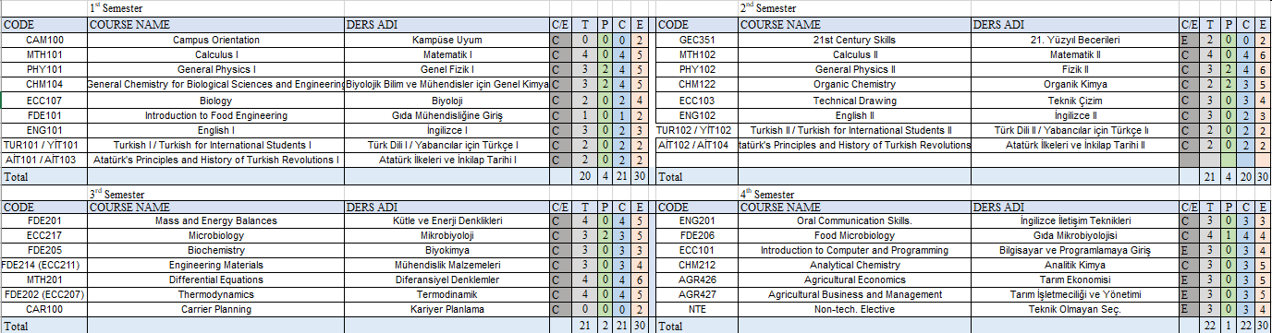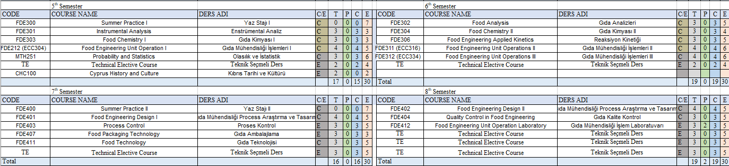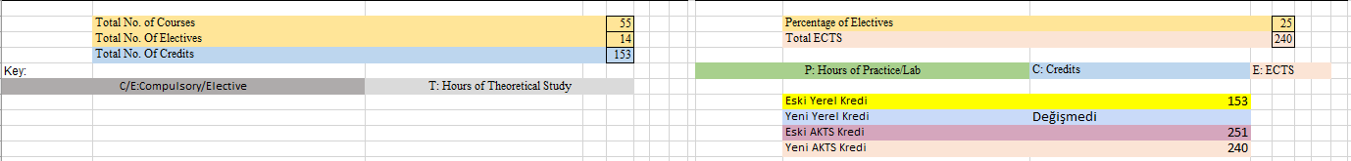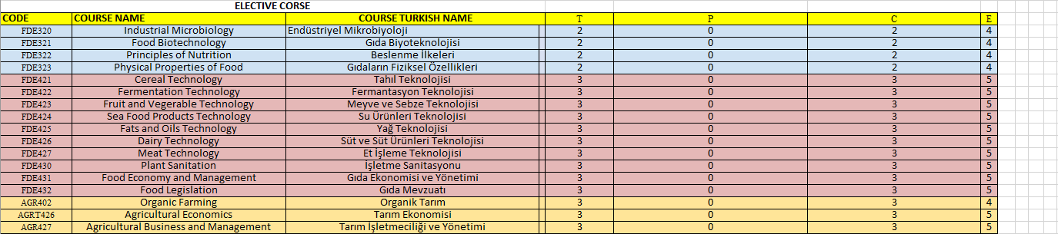
Drive Link:
https://ziraat.neu.edu.tr/wp-content/uploads/sites/153/2026/02/17/Gida-Muhendisligi-Mufredat-1.pdf?ver=b8cb56328b712ede7814a522eb46a753.
8.2. Common Compulsory Courses Offered University-Wide
In this section, common compulsory courses that must be taught in all undergraduate programs within the university are included. These courses are offered in a standard format across all programs in accordance with the principles set by the Council of Higher Education (YÖK) and constitute one of the fundamental components of university education.
Each academic program should carry out its course planning by taking into account the content and learning outcomes of the common compulsory courses listed below. In this context, programs should integrate the relevant courses into their curriculum in accordance with the educational plan and make necessary adaptations in line with the objectives, scope, and content of the courses.
Below, descriptions and core content information of the common compulsory courses applicable to all programs across the university are presented.
Common Course Contents Link:
https://docs.google.com/document/d/1lwVlPmwL_nGJVTn5JcTxdegXtaPN4wgK/edit?usp=sharing&ouid=104243359773687705470&rtpof=true&sd=true.

8.3. Course Syllabus
The course syllabi for the Food Engineering undergraduate program are included in the appendix.

9. PRINCIPLES OF PROGRAM ASSESSMENT AND EVALUATION
9.1. Exam Rules
All information regarding exam rules, variety of assessment tools, etc., will be shared by the Assessment and Evaluation Coordination Office.

9.2. Letter Grade Conversion Table
This section includes the conversion table for letter grades that students receive for each course at the end of the semester, along with brief explanations of the grades. Students’ academic performance is evaluated by the instructor based on in-semester work and end-of-semester exam results. Letter grades are expressed with a coefficient value on a 4.00 scale and also correspond approximately to achievement ranges on a 100-point scale. This system is used as the basis for calculating the student’s overall grade point average (GPA).
The coefficients of letter grades and their equivalents on a 100-point scale are shown below.
Score | Letter Grade
  Coefficient
90-100 | AA | 4
85-89 | BA | 3.5
80-84 | BB | 3
75-79 | CB | 2.5
70-74 | CC | 2
60-69 | DC | 1.5
50-59 | DD | 1
49 and below | FF | 0

Additional Grades Provided Beyond the Above Letter Grades:
I–Incomplete, S–Satisfactory, P–Progressing, EX–Exempt, W–Withdrawn, NA–Absent
(I) Grade is assigned by the instructor to students who, due to illness or other valid reasons, are successful during the term but have not completed the requirements of the course. A student receiving an (I) grade must complete the missing requirements and obtain a grade within 15 days from the date the grades are submitted to the Student Affairs Office. Otherwise, the (I) grade automatically converts to (FF). However, in cases of prolonged illness or similar situations, the duration of the (I) grade may be extended until the beginning of the next registration term with the recommendation of the Department Chair and the approval of the Faculty Administrative Board.
(S) Grade is given to students who pass courses that are not included in the grade point average. The (S) grade is also given for courses previously taken and recognized as equivalent by the Faculty Administrative Board to students transferring from another university or re-enrolling via entrance exam. Students transferring from outside who are required to retake any course according to regulations cannot receive an (S) grade. The (S) grade is not included in GPA calculations.
(P) Grade is given to students who are continuing courses that are not included in GPA calculations.
(U) Grade is given to students who fail courses that are not included in GPA calculations.
(EX) Grade is given to students exempted from certain courses based on a departmental exemption exam as determined by the Senate. The (EX) grade is not included in GPA calculations but is shown on the transcript.
(W) Grade is used for a course withdrawn after the normal add/drop period within the first ten weeks of the term with the recommendation of the advisor and the permission of the instructor. The following rules apply:
(a) Students cannot withdraw from courses in the first two semesters of their undergraduate program.
(b) Students cannot withdraw from a course they are required to retake, previously received a (W) grade, or is not included in GPA. Withdrawal is not allowed if the student’s course load falls below 2/3 of the normal load. A student may withdraw from a maximum of one course per term and up to six courses throughout their undergraduate education with advisor recommendation and instructor approval.
(NA) Grade is given to students who, despite being enrolled, do not attend the course.
I | Incomplete
S | Satisfactory Completion
U | Unsatisfactory
P | Successful Progress
NP | Not Successful Progress
EX | Exempt
NI | Not included
W | Withdrawal
NA | Never Attended
ECTS Credit Calculation Information for Near East University
- In the ECTS (European Credit Transfer and Accumulation System), 60 credits are assigned for one academic year (two semesters), and 30 credits are assigned for a single semester. Students must accumulate a total of 240 ECTS credits over four years of study in order to graduate.
- The ideal method of calculation is based on measuring the total time a student spends on a particular course. Accordingly, the total workload for all courses taken in a semester is considered to correspond to 30 ECTS credits, and each course's ECTS value is determined based on its proportion of the total workload. At Near East University, 1 credit corresponds to 30 hours of workload.
For example, a 1 ECTS credit course requires a student to spend 30 hours of total workload. A 3 ECTS credit course is assumed to involve 90 hours of student effort (including class attendance, preparatory reading, assignments, projects, literature review, and exam preparation). In this context, since 1 credit = 30 hours of workload, a course requiring 90 hours of work will have an ECTS value of 90/30 = 3 ECTS credits.

10. STUDENT ADMISSION AND REGISTRATION REQUIREMENTS
At Near East University, education is provided at associate, undergraduate, and graduate levels. The language of instruction is Turkish, and English or other languages may be used when necessary. Examination and evaluation principles are regulated by separate regulations. Student admissions are conducted through the Student Affairs Office within the framework of rules determined by the Senate. Admission to preparatory, associate, and undergraduate programs is carried out either through special exams or without exams for foreign students. Conditions for graduate programs and transfer students are specified in the relevant regulations. Special students may only enroll in certain courses and cannot receive a diploma. Admission and registration conditions for foreign students who are not citizens of the TRNC or Turkey are conducted in accordance with the regulations titled “Admission and Registration Conditions for Foreign Students Who Are Not Citizens of the Turkish Republic of Northern Cyprus or the Republic of Turkey to Higher Education Institutions,” under Articles 65/2005, 21/2008, 40/2009, and 23/2007 of YÖDAK Law No. 11. If deemed necessary, prospective students may be admitted to a one-year scientific preparatory program. Registration is completed when the required documents and tuition fees are submitted within the specified dates. Students are required to renew their registrations every semester. The proficiency level of English preparatory class students is determined by exams, and this education lasts a maximum of two years. Associate, undergraduate, and graduate programs are conducted according to their respective regulations. Students may also take courses for teaching certification. Diplomas for associate, undergraduate, and graduate programs are awarded to those who successfully complete their studies. The issuance of diplomas and provisional graduation certificates is determined by the Senate. Students' grades are officially recorded, and certified documents are provided upon request. No tuition refunds are given to students who voluntarily withdraw or cancel their registration. Students may take leave for health, military service, financial reasons, or educational purposes, and this period is not counted toward the duration of their studies. Students returning from leave must renew their registration to continue their education. Students are guided by their academic advisors. Mandatory internships, disciplinary procedures, scholarships, and health services are regulated according to relevant regulations.

11 Horizontal and Vertical Transfer Opportunities
11.1. Horizontal Transfer Opportunities
This section outlines the procedures and principles to be followed for horizontal transfer applications to the Classroom Teaching Department at Near East University. All horizontal transfer processes are conducted within the framework of the Near East University Horizontal Transfer and Credit Transfer Directive.
Students applying for horizontal transfer must:
- Have no disciplinary penalties,
- Have a minimum cumulative grade point average of 2.00/4.00 or 60/100,
- Have successfully completed a sufficient number of courses compatible with the curriculum of the program they wish to transfer into.
For transfers based on the centralized placement score, students must meet the minimum score requirement of the program they wish to transfer to for the year of application.
Applications must be submitted within the dates announced by the university, and all required documents must be delivered completely to the relevant academic unit. Applications are evaluated according to students' academic success and available quotas.
Decisions regarding:
- Course exemptions,
- Class equivalencies,
are made by the Faculty Executive Board based on the opinion of the Department Chair. During the evaluation process, particular attention is given to the alignment of pedagogical formation and teacher professional knowledge courses.
Course equivalency is based on the compatibility of the content of courses previously taken by the student at their former higher education institution with those of the program they intend to transfer into.
Applications for horizontal transfer due to special circumstances (e.g., war, natural disasters, health issues, etc.) are evaluated separately according to relevant legislation. In such cases, students may be required to submit additional documentation.

11.2. VERTICAL TRANSFER OPPORTUNITIES
This section outlines the procedures and principles to be followed for vertical transfer applications to the Near East University Department of Primary Education. Students applying for vertical transfer are required to participate in the Vertical Transfer Exam (DGS) administered by the Assessment, Selection and Placement Center (ÖSYM). Preferences are made based on the exam scores, and student placements are carried out by ÖSYM accordingly.

12. RECOGNITION AND CREDIT TRANSFER OF PREVIOUS LEARNING
Students enrolled in the Near East University Food Engineering Program may request exemption for courses they have successfully completed at previous higher education institutions until the end of the second week of the semester in which the course registration is made. Applications must be submitted in writing to the relevant academic unit and must include approved course descriptions and an official transcript. For courses taken at foreign higher education institutions, the equivalency of these courses must be approved by the Higher Education Council (YÖK) for exemption requests to be accepted. No course exemption is granted between students simultaneously registered in both an associate degree and a bachelor's degree program. Exemption requests are evaluated by the relevant departmental committee, considering the course content, credits, and the student’s success status. Approved courses are recorded on the student’s transcript with the letter grade and included in the cumulative GPA. Exemptions are not granted for failed courses. Exemptions can be granted without credit equivalency for common compulsory courses such as Atatürk’s Principles and History of Revolution, Turkish Language, and Foreign Language. Students may only take the exemption exam for these courses once. If the total ECTS credits of exempted courses exceed 70% of the total ECTS credits of the semester in which the student is registered, the student is placed into the next grade level. However, students who are placed into a higher class cannot take upper-level courses during the first academic year following this placement. Objections to exemption and placement decisions can be submitted within two weeks from the date the results are notified to the student. In cases of horizontal and vertical transfers, course exemption requests are evaluated by the faculty or school board based on the opinion of the departmental committee. For exemption from the foreign language preparatory class, a certain level of language proficiency must be demonstrated through exam results accepted by the university.

13. INTERNATIONAL PROGRAMS AND EXCHANGE OPPORTUNITIES
Near East University (NEU) offers its students international exchange and internship opportunities, particularly through the Europe-centered Erasmus+ Program, which provides study and internship options. Through this program, students and academics are given the chance to study and intern abroad in European Union member countries. Students wishing to participate in the Erasmus+ Program must have completed at least their first year, demonstrate a certain level of academic achievement, and provide proof of foreign language proficiency required by the relevant program.
In addition, NEU conducts exchange activities through various international student associations in different fields. These associations include:
- IFMSA (Medicine)
- IADS (Dentistry)
- IPSF (Pharmacy)
- IVSA (Veterinary Medicine)
Within these programs, research and clinical internship exchange opportunities are offered to students. During the summer terms, practical training sessions, joint research projects, and cultural activities are organized in collaboration with these associations, involving students from different countries.
Thanks to NEU’s active partnerships with 114 universities from 44 countries, students have opportunities to study and intern abroad while also learning in an intercultural environment on the campus in the Turkish Republic of Northern Cyprus (TRNC). NEU maintains reciprocal collaborations with numerous higher education institutions across Europe, Asia, America, and Africa. Students can study for a semester or full academic year, intern, or participate in international research projects at these universities.
To provide global experience, the university does not limit itself to Erasmus+ but also conducts student exchange activities under the Mevlana and Farabi programs. The Mevlana Program particularly offers reciprocal exchange opportunities with universities in Turkey, while the Farabi Program supports student exchanges among domestic universities. Through these programs, students have the chance to enhance their academic knowledge and gain cultural insights by experiencing diverse cultures.
Throughout the entire process, the NEU International Office provides comprehensive support starting from the application stage, including advisory services, document and application handling, accommodation, and visa matters. Students are informed and guided by expert staff at every step of the exchange process.

14. ACCREDITATION AND QUALITY ASSURANCE OF THE PROGRAM
14.1. Quality Policy
The Department of Food Engineering adopts a quality policy that aims to continuously enhance the quality of its education and training activities, support the production of scientific knowledge, and educate qualified food engineers for society in line with the mission and vision of the University and the Faculty. The program offers education in two languages, Turkish and English, with the objective of equipping its graduates with the knowledge, skills, and competences necessary to be competitive at both national and international levels.
The quality policy of the Department is based on educating individuals who possess a strong foundation in basic engineering knowledge in the field of food engineering, high practical competence, commitment to ethical values, a well-developed sense of social responsibility, and openness to lifelong learning. Accordingly, the curriculum is regularly reviewed and improved by taking into consideration current scientific and technological developments, sectoral needs, stakeholder feedback, and program learning outcomes.
In education and training processes, student-centered approaches, practice- and laboratory-based learning are prioritized, while transparency in assessment and evaluation processes and alignment with learning outcomes are ensured. Research and development activities are structured to enhance the scientific productivity of academic staff and students and to transfer the accumulated knowledge to education and society. The Department adopts a culture of quality assurance as a fundamental principle by integrating it into all academic and administrative processes, with a focus on sustainable continuous improvement.

14.2. Accreditation Process of the Program
The Food Engineering Program adopts equivalency-based quality assurance processes in order to ensure quality assurance and to maintain alignment of its education and training activities with national and international standards. The undergraduate program delivered in Turkish holds equivalency recognition from YÖDAK, while the undergraduate program delivered in English holds equivalency recognition from both the Council of Higher Education (YÖK) and YÖDAK. These equivalencies demonstrate that the program’s curriculum structure, learning outcomes, faculty qualifications, and educational infrastructure comply with the relevant national standards.
Although the Department does not currently hold a program accreditation awarded by a different national or international accreditation body, its quality assurance system is continuously strengthened within the scope of preparation for future accreditation processes. In this context, program educational objectives and learning outcomes are regularly reviewed; course–program outcome mappings are conducted; student and graduate feedback is evaluated; and internal evaluation reports are prepared to plan and implement improvement actions. In addition, efforts are undertaken to update the curriculum, enhance practical training and internship processes, and align graduate qualifications with sector expectations, based on feedback and input received from external stakeholders such as industrial organizations, food production and processing facilities, factories, hotel and restaurant enterprises, public institutions, and professional bodies including the Chamber of Food Engineers.
Furthermore, systematic efforts are carried out to improve faculty qualifications, increase research and development activities, enhance assessment and evaluation processes, and strengthen stakeholder participation. These efforts aim to establish the institutional infrastructure required for applications to national and/or international accreditation processes in the forthcoming periods.
The Department of Food Engineering aims to further advance the quality of education assured by the equivalency recognitions of the TRNC Ministry of National Education, YÖK, and YÖDAK in line with a continuous improvement approach; to regard accreditation processes as a natural component of the quality culture; and to achieve sustainable development in education, research, and community service accordingly.

14.3. Quality of Education
The Food Engineering Program is periodically reviewed in line with innovations in education and industry as well as evolving needs; course contents are updated, new courses in the field of food engineering are incorporated into the curriculum, and courses that have become outdated are removed from the program. This process is carried out in a systematic manner within the framework of established schedules and mechanisms, with the participation of the departmental academic board and relevant stakeholders.

14.4. Research and Development Activities
In line with its quality policy, the Department of Food Engineering places strong emphasis on scientific and innovative research and development activities based on a contemporary approach to education. These activities, which aim to enhance the quality of the teaching process, are carried out within the framework of effective teaching methods, the use of educational technologies, assessment and evaluation practices, and inclusive, student-centered approaches. Research and development activities are structured to support the development of critical thinking, problem-solving, and lifelong learning skills of prospective food engineers. In this context, the development of projects that establish coherence between theoretical knowledge and practical application and that are open to national and international collaboration is actively encouraged.

14.5. Continuous Improvement Process

Within the scope of quality assurance, the Food Engineering Program adopts a continuous improvement approach to enhance the teaching and learning process. In line with feedback received from students, graduates, and stakeholders, course contents, teaching methods, and practical implementation processes are regularly reviewed. Based on the data obtained, educational activities are updated and initiatives that support the professional development of prospective food engineers are planned.

15. GRADUATION REQUIREMENTS AND AWARDED DEGREE
15.1. Graduation Requirements
To graduate from the Near East University Food Engineering Undergraduate Program, a student must complete a total of 240 ECTS credits, including compulsory, common compulsory, and elective courses within the curriculum. Additionally, the student’s cumulative (overall) academic grade point average must be at least 2.00 and successfully complete all courses in the program with a minimum grade of DD/S. The practicum and internship processes must be fully completed. When all these academic and administrative requirements are met, the student becomes eligible to receive the Food Engineering Bachelor's degree diploma.

15.2. Awarded Degree
Students who successfully complete the Near East University Food Engineering Undergraduate Program are awarded a bachelor's degree in Food Engineering. Graduates are granted the title of 'food engineer.'

16. DIPLOMA SUPPLEMENT
The diploma supplement is included in the appendix.
Drive Link:
https://docs.google.com/document/d/1dk1ySaYaPuRbkPsWkuLWrzzb5NRZ8Xxo/edit.

17. EMPLOYMENT OPPORTUNITIES FOR GRADUATES AND ACCESS TO GRADUATE PROGRAMS
17.1. Employment Opportunities for Graduates
Graduates of the Department of Food Engineering may find employment as food engineers, food quality and safety inspectors, or quality control officers in the production, distribution, sales, marketing, procurement, and quality control departments of factories producing food and food additives; in food production and food control units of supermarkets; and in institutions responsible for food inspection and control. They may also work as food quality control supervisors in catering services, patisseries, and similar food-producing companies, as well as in institutions that prepare, procure, and serve daily meals, such as educational institutions. Employment opportunities are also available in companies engaged in food packaging, in decision-making positions as engineers or researchers within the Ministries of Agriculture and Forestry and Health, in roles related to policymaking and food inspection, and as educators in institutions providing education in the field of food. The educational institutions with which the University collaborates, along with its strong connections with the industry, provide support to graduates throughout their employment processes.

17.2. Access to Graduate Programs
Graduates of the Food Engineering Program are eligible to apply for master’s and doctoral programs upon completion of their undergraduate education. Information is provided regarding application requirements and program regulations, and guidance is also offered on inter-university transfer opportunities and scholarship possibilities. The postgraduate education process deepens graduates’ professional knowledge and skills, enhances their academic career prospects, and contributes to the development of their expertise in the field of education.

18. ADDITIONAL INFORMATION
The Department of Food Engineering at Near East University is structured in line with the principles of food safety, quality control, food processing technologies, and sustainable production, and aims to provide a comprehensive education that integrates theoretical knowledge with practical engineering skills. The program, offered in both Turkish and English as languages of instruction, seeks to educate food engineers who are capable of competing at national and international levels.

Difference from Similar Programs
The Food Engineering Program not only provides fundamental knowledge in engineering and food sciences but also focuses on equipping students with competencies in food safety, quality management systems, regulatory knowledge, and industrial applications. With its practice-oriented course structure, modern laboratory infrastructure, and strong collaborations with industry, the program distinguishes itself from similar programs by enabling students to gain professional experience prior to graduation.

Opportunities Offered
Within the scope of the program, students benefit from compulsory and voluntary internship opportunities through collaborations with food production and processing facilities, factories, hotel and restaurant enterprises, catering companies, and public institutions. In addition, early engagement with the sector is supported through events organized in cooperation with the Chamber of Food Engineers, including professional information sessions and career days. Following graduation, students continue to receive support through job placement networks and career guidance activities.

Success Stories
Graduates of the Department of Food Engineering are employed in various positions in the food industry, including production, quality control, research and development, food safety, as well as in public institutions and the private sector. Some graduates pursue postgraduate education and advance toward academic careers, while others establish their own enterprises and contribute innovative solutions to the food sector. Graduate achievements are shared with current students through alumni meetings and departmental events.

Additional Activities
Throughout the program, seminars, guest speaker events, technical visits, and online webinars are organized on topics such as food safety, sustainable food systems, innovative food technologies, and sectoral practices. These activities enhance students’ professional awareness and enable them to closely follow developments in the industry.

