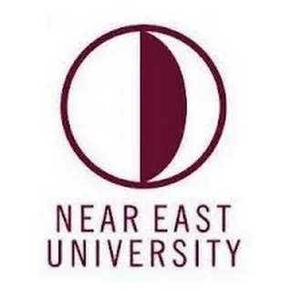
Program Catalogue Preparation Guide

Faculty of Agriculture
Department of Animal Science

1. General Writing Guidelines for the Program Catalog 3
1.1. Establishment of the Faculty 3
A) History of the Faculty and Academic Processes 3
B) Educational Policy and Academic Objectives 4
C) Physical and Academic Infrastructure 4
D) Accreditation and Quality Policy 4
1.2. Faculty’s Mission, Vision, and Core Values 5
A) Mission 5
B) Vision 5
C) Core Values 6
1.3. Faculty’s Aims and Objectives 6
A) Writing of Objectives 6
B) Writing of Goals 7
C) Goals and Objectives Covering the Field of Education 7
D) Goals and Objectives Covering the Field of Research 8
E) Goals and Objectives Covering Contributions to Society and Educational Services 8
1.4 Organizational Chart of the Faculty 8
1.5. Faculty Administration 11
1.6. Academic Staff of the Faculty 11
A) Academic Structure and Departments 11
B) Distribution and Strength of Academic Personnel 11
C) Academic Development and Quality Policy 12
1.7. Programs within the Faculty 12
2. GENEREAL INFORMATION OF THE PROGRAM 14
2.1. Brief History and Development of the Program 14
2.2 Type of Education of the Program. 14
2.3. Educational Level of the Program 14
2.4. Language of Instruction of the Program 15
2.5. Duration of the Program 15
2.6. Organizational Chart of the Program 15
2.7. Program Coordinator 16
2.8. Program Management and Academic Staff 16
3.MISSION AND VISION OF THE PROGRAM 17
3.1. Mission 17
3.2. Vision 17
4.CORE VALUES OF THE PROGRAM 18
5.FIELDS OF ACTIVITY OF THE PROGRAM 18
6. OBJECTIVES AND GOALS OF THE PROGRAM 19
6.1. Statement of Purpose 20
6.2. Statement of Goals 20
A) Objectives and Goals Covering the Field of Education 20
B) Objectives and Goals Covering the Field of Research 21
C) Objectives and Goals Covering Contributions to Society and Educational Services 21
7. PROGRAM COMPETENCIES 21
7.1. Program Learning Outcomes 21
7.2. Relationship Between Program Learning Outcomes and NQF Qualifications 23
A) Structure of the NQF 23
B) Preparing a Matrix of Program Learning Outcomes and NQF Alignment 24
7.3. Relationship Between Courses and Program Learning Outcomes 25
A) Preparing a Matrix of Courses and Program Learning Outcomes Relationship 25
8.COURSE LIST 26
8.1. Distribution Tables of Core and Elective Courses by Semester for the Program 26
A) Semester-wise Distribution of Courses 26
B) Types and Number of Elective Courses 26
C) ECTS (European Credit Transfer and Accumulation System) Information and Local Credits 26
D) Course Code, Title, and Status 27
E) Presentation in Visual or Table Format 27
8.2. Common Compulsory Courses Offered University-wide 27
8.3. Course Syllabi 27
9.ASSESSMENT AND EVALUATION PRINCIPLES OF THE PROGRAM 46
9.1. Exam Rules 46
9.2. Letter Grade Conversion Table 46
10.STUDENT ADMISSION AND ENROLLMENT REQUIREMENTS 48
11.HORIZONTAL AND VERTICAL TRANSFER OPPORTUNITIES 49
11.1. Horizontal Transfer Opportunities 49
11.2. Vertical Transfer Opportunities 50
12.RECOGNITION AND EVALUATION OF PRIOR LEARNING 50
13.INTERNATIONAL PROGRAMS AND EXCHANGE OPPORTUNITIES 51
14.PROGRAM ACCERDITATION AND QUALITY ASSURANCE 51
14.1. Quality Policy 52
14.2. Program Accreditation Process 52
14.3. Quality of Education 52
14.4. Research and Development Activities 53
14.5. Continuous Improvement Process 53
15. GRADUATION REQUIREMENTS AND DEGREE AWARDED 53
15.1. Graduation Requirements 53
15.2. Degree Awarded 54
16.DIPLOMA SUPPLEMENT 54
17. EMPLOYMENT OPPORTUNITIES FOR GRADUATES AND ACCESS TO GRADUATE PROGRAMS 55
17.1 Employment Opportunities for Graduates 55
17.2. Access to Graduate Programs 56
18. ADDITIONAL INFORMATION 56

1. GENERAL WRITING GUIDELINES FOR THE PROGRAM CATALOGUE
The general writing guidelines to be followed when preparing the program catalogue are listed below.

- A formal and academic tone must be used.
- First-person singular and plural pronouns should not be used.
- It must be written in accordance with the spelling rules of the Turkish Language Association (TDK).
- A clear, simple, and effective style of expression must be used. Long and complex sentence structures should be avoided.
- Each section within the program catalogue must:
o The content must be original and informative.
o It must maintain internal consistency.
o The terminology used should be coherent throughout.
o Headings must be clear and hierarchical.
- The text style should be Nunito; main section titles 14 pt, primary headings 14 pt, subheadings 12 pt, and the main body text 12 pt.
- All main section titles must be written in uppercase letters. (Example of main section title: FACULTY ABOUT)
- Primary headings must have initial capital letters and be bolded (Example of primary heading: Establishment of the Faculty).
- Subheadings must have initial capital letters and be bolded (Example of subheading: History of the Faculty and Academic Processes).
- Paragraphs must be written concise and clear.
- Bullet points may be used where necessary.
- Numerical data and date information must be written after verifying their accuracy.
- Academic referencing rules must be observed in cited sentences (must comply with APA 7 format).
- Repetitions in sentence expressions should be avoided.
1.1. ESTABLISHMENT OF THE FACULTY
Near East University Faculty of Agriculture was established in 2021. It has three separate departments. These departments are Landscape Architecture, Food Engineering and Animal Science. The duration of education in all three departments is four years.
Faculty of Agriculture, with its qualified and expert academic staff, aims to train individuals, who possess professional agricultural, food and environmental knowledge, subject matter expertise, and general culture; that are inquisitive, questioning, and proficient in technology, committed to ethical values, and equipped with strong communication skills.
The Faculty of Agriculture considers contributing to the overall quality of the education system by nurturing agricultural enginners, food engineers, landscape architects who are sensitive to societal needs, are open to collaboration, and capable of creative and critical thinking, thereby promoting quality education in the institutions where its graduates serve.

- History and Academic Processes of the Faculty

Near East University Faculty of Agriculture was established in 2021 and started its education activities in line with the decision of the Ministry of National Education and Culture of the Turkish Republic of Northern Cyprus and the Higher Education Supervision and Accreditation Board (YÖDAK) (Decision Number - YOD 0.00- 223/02-21/E. 542).
After the establishment of the faculty, the Departments of Landscape Architecture and Food Engineering, which were previously providing education under other faculties, were deemed appropriate to be transferred to the Faculty of Agriculture by YÖK with the decision numbered E- 75850160-301.01.01-11123 on 16.02.2022.
The Department of Landscape Architecture has programs offering English education at undergraduate and graduate levels. There are programs offering undergraduate education in English and Turkish in the Department of Food Engineering. The undergraduate English program of the Department of Animal Science received permission to start education on October 5, 2023 (YÖDAK Decision number: 2023/ 45-9). There is a program in the Department of Animal Science that offers undergraduate education in English.

B) Educational Policy and Academic Objectives

Faculty of adopts a contemporary educational approach in line with a progressive educational philosophy, implementing a student-centered teaching model that encourages interdisciplinary collaboration. The educational programs are structured in accordance with international standards and successfully undergo accreditation processes within the scope of quality assurance. Graduates of the faculty contribute to the professional and academic fields as competent, creative individuals with strong ethical values. Faculty members contribute to science through their scientific research, R\&D activities, and community projects, aiming to lead societal development.

C) Physical and Academic Infrastructure
Administrative Offices: The Dean's Office of the Faculty of Agriculture is located on the fourth floor of the Faculty of Pharmacy building. Faculty
Faculty of Agriculture offers students a variety of social and academic study spaces through classrooms designed in line with a modern educational approach, technologically equipped laboratories, and digital learning platforms. In addition, The Food Engineering Department has one research lab at Veterinary Medicine building: AGRI-VET Research Laboratory.
Within the framework of cooperation between the Ministry of Natural Resources and Agriculture, private Landscape companies from Antalya – Turkey, private food companies and animal production companies the faculty provides students with internship and practical training opportunities. This support enables students to gain professional experience prior to graduation.

D) Accreditation and Quality Policy
Faculty of Agriculture adopts national and international quality standards in its educational and research processes; accordingly, it aims to enhance the quality of education through a continuous improvement approach. The faculty actively participates in national and international accreditation processes, regularly reviewing and developing its educational programs. The programs are structured considering professional ethics, safety standards, and current requirements, aiming to equip students with competent and well-prepared professional skills.

1.2. Faculty Mission, Vision and Core Values

- Mission
As with all the studies undertaken and carried out by our university throughout the island, our Faculty of Agriculture aims to serve our country and humanity by creating a contemporary learning and progress environment by contributing to the development of new knowledge, technology and products, especially within the framework of sustainability and ethical principles in the agricultural field. In this context, our faculty was established with the aim of training landscape architects, food engineers and zootechnicians who are innovative, highly aware and capable of working interdisciplinary.

- Vision
Our aim is to be a student-oriented faculty that contributes to economic, social, community and cultural life at both national and international levels, uses technology effectively, keeps sustainability at its core in all its dimensions, and is a quality and pioneer in science.

- Core Values
Student Oriented: To provide a participatory and supportive educational environment that centers on students' academic, social and professional development.
Scientific and Productivity: Encouraging thinking skills based on scientific methods; Adopting a creative and productive approach in research, design and application processes.
Sustainability: Based on sustainable design principles that consider the protection of natural resources, environmental sensitivity and ecological balance.
Accessibility and Equity in Education: Creating an inclusive, diverse, and accessible learning environment that provides equal opportunities for all.
Commitment to Ethical Principles: Aiming to cultivate individuals who respect academic and professional ethical values ​​and are responsible towards society and the environment.
Collaboration and Participation: Adopting an approach that values ​​interdisciplinary studies, public-private sector collaborations, and stakeholder engagement.
Innovation and Continuous Improvement: Developing a vision that adapts to changing global conditions, monitors digitalization and new technologies, and encourages continuous learning.
These core values ​​define the department not only as an academic training center but also as an institution that trains socially responsible, environmentally conscious, and innovative landscape architects, food engineers, and zootechnical agricultural engineers.

1.3. Faculty Aims and Goals
A) Aims and Goals Covering the Field of Education:
Aim 1: To train graduates who integrate theoretical knowledge with practical skills in the fields of Landscape Architecture, Food Engineering, and Animal Science.
Goal 1.1: To develop workshop, fieldwork, and project-based courses where students can apply their subject knowledge in the field.
Goal 1.2: To create accessible and digitally supported learning environments equipped with current technologies.
Goal 1.3: To enable students to acquire professional competence at national and international levels.

Aim 2: To train critical-thinking, creative, and sustainability-oriented designers, zootechnical agricultural engineers and food engineers.
Goal 2.1: To create course content that develops problem-solving, analysis, and critical thinking skills in design processes, food engineering and animal sciences
Goal 2.2: To encourage students to produce designs that is highly environmentally conscious and embraces sustainability principles.
Goal 2.3: To train innovative and entrepreneurial individuals who are open to interdisciplinary studies.

B) Aims and Objectives Covering the Research Area:
Aim 1: To produce scientific knowledge and increase research capacity in the field of landscape architecture, food engineering and animal sciences
Goal 1.1: To create teaching and project environments which encourage students' participation in research processes.
Goal 1.2: To improve the infrastructure and incentive opportunities for academic staff to conduct research projects.
Goal 1.3: To increase the department's visibility in national and international scientific events.
Goal 1.4: To produce scientific studies focused on sustainable, nature-based solutions.

Aim 2: To conduct research that will produce solutions to environmental, social, and cultural problems on a local and global scale.
Goal 2.1: To develop interdisciplinary projects on urban open spaces, rural landscapes, climate change and ecological planning, rural agriculture, food health and safety, food packaging, animal husbandry, animal nutrition, animal welfare and hygiene.
Goal 2.2: To introduce students to the role of a researcher by encouraging field-based, applied research.
Goal 2.3: To increase the quantity and quality of academic publication production.

1.4. Faculty Organizational Chart
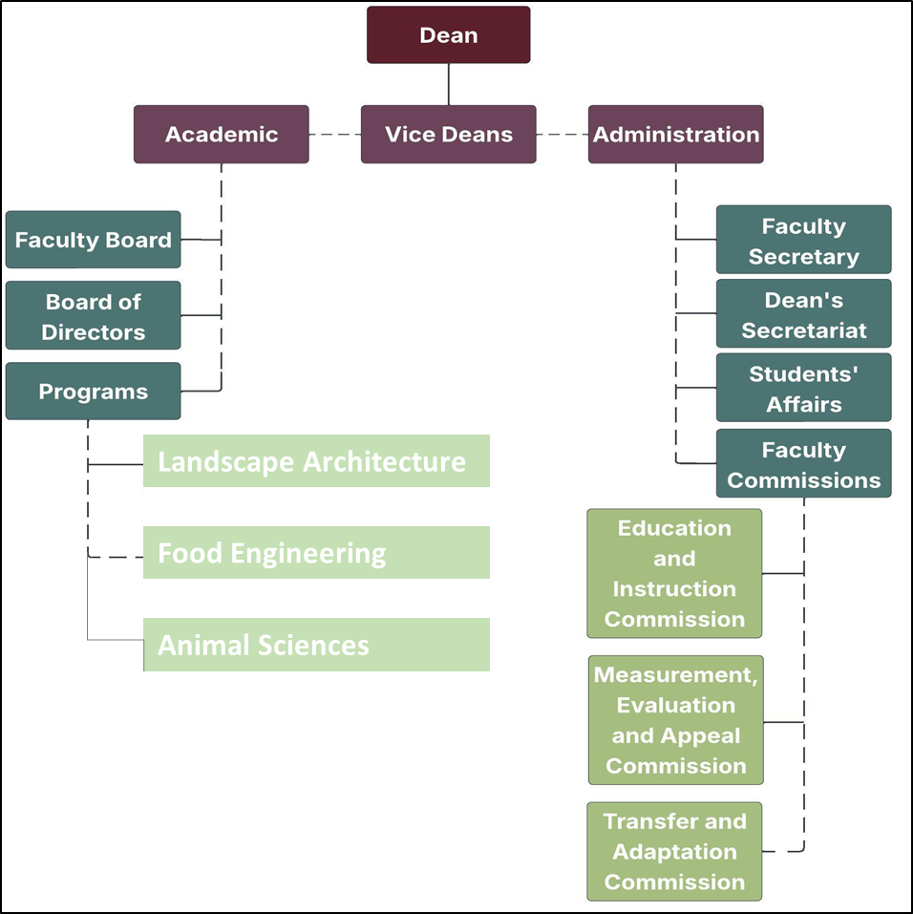
Figure 1. Organizational Chart
1.5. Faculty Administration
There are five faculty members on the faculty board of the Faculty of Agriculture. The titles, names and duties of these members are listed in Figure 2 below.

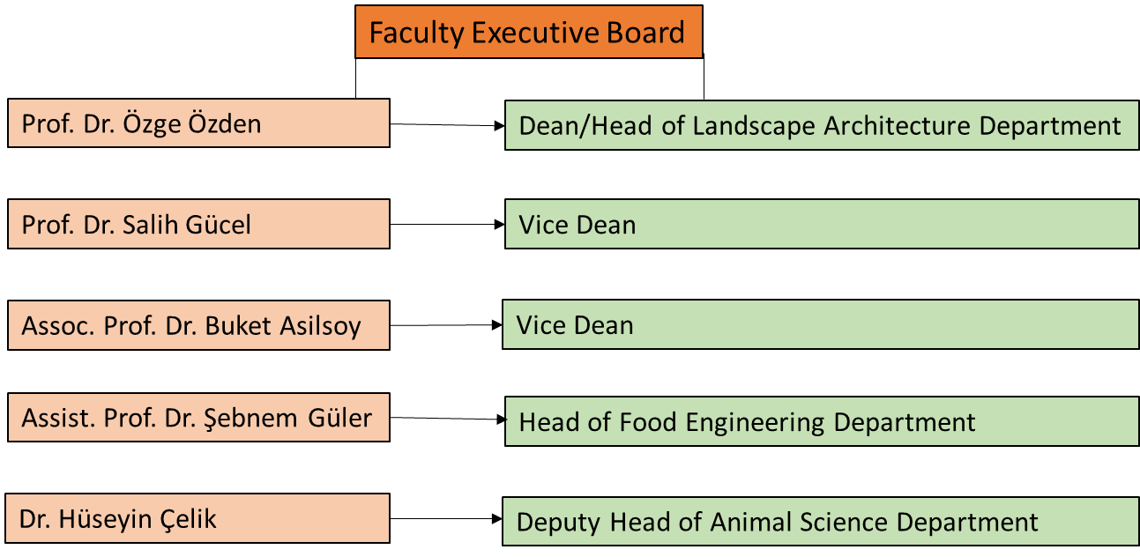

Figure 2: Faculty Executive Board

There are also five faculty members on the faculty board of the Faculty of Agriculture. The titles, names and duties of these members are listed in Figure 3 below.

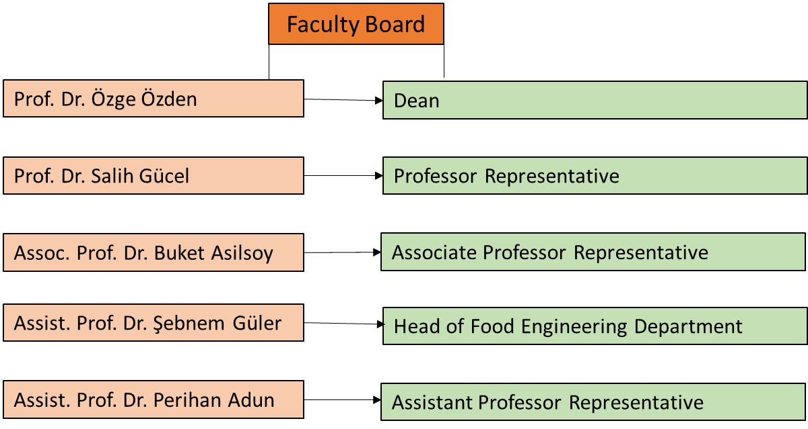

Figure 3: Faculty Board

1.6. Academic Staff of the Faculty

A) Academic Structure and Main Disciplines

The Faculty of Agriculture comprises three separate departments: Landscape Architecture (English), Food Engineering (Turkish and English), and Animal Science (English) (Figure 4). The duration of study in all three departments is four years. Tables 1-5 show the departments within the faculty.

Figure 4. Chart showing 3 different Departments

Table 1. List of Full-Time Faculty Members Teaching in Landscape Architecture Undergraduate (English Program)
 | Landscape Architecture BSc Programme
 | 2024-2025 FALL | 2024-2025 SPRING | 2025-26 FALL
Prof. Dr. Özge Özden | √ | √ | √
Prof. Dr. Salih Gücel | √ | √ | √
Assoc. Prof. Dr. Buket Asilsoy | √ | √ | √
Assoc. Prof. Dr. Can Kara | √ | √ | -
Dr. Sinem Yıldırım | √ | √ | √

Table 2. List of Part-Time Instructors Teaching in Landscape Architecture Undergraduate (English Program)
 | Landscape Arhitecture BSc Programme
 | 2024-2025 FALL | 2024-2025 SPRING | 2025-26 FALL
Muhammed Adeel | √ | √ | √
Derviş Ali Özersoy | √ | √ | √
Dr. Aysel Mirkasımova | √ | √ | √
Assist. Prof. Dr. Serhat Usanmaz | √ | - | √

Table 3. List of Full-Time Faculty Members Teaching in Food Engineering Undergraduate Programs (Turkish and English Programs)
 | TURKISH PROGRAMME |  |  | ENGLISH PROGRAMME
 | 2024-2025 FALL | 2024-2025 SPRING | 2025-26 FALL | 2024-2025 FALL | 2024-2025 SPRING | 2025-26 FALL
Assist Prof. Dr. Perihan Adun | √ | √ | √ | √ | √ | √
Assist. Dr. Şebnem Güler | √ | √ | √ | √ | √ | √
MSc. Mehmet Karagözlü | √ | √ | √ | √ | √ | √

Table 4. List of Part-Time Lecturers Teaching in Food Undergraduate Programs (Turkish and English Programs)
 | TURKISH PROGRAMME |  |  | ENGLISH PROGRAMME
 | 2024-2025 FALL | 2024-2025 SPRING | 2025-2026 FALL | 2024-2025 FALL | 2024-2025 SPRING | 2025-2026 FALL
Prof. Dr. Nevzat Artık | √ | √ | √ | √ | √ | √

Table 5. List of Full-Time Faculty Members Teaching in Animal Sciences Undergraduate Programme (English Programme)
 | ENGLISH PROGRAMME
 | 2024-2025 FALL | 2024-2025 SPRING | 2025-26 FALL
Prof. Dr. Dilek Arsoy | √ | √ | -
Dr. Hüseyin Çelik | √ | √ | √
Assist. Prof. Dr. Valiollah Palangi | - | - | √

- Distribution of Academic Staff and Human Resources Capacity
Faculty of Agriculture consist of total number of 9 Full time academics. Table 6 is showing distribution of academic staff by Programs.

Table 6. Distribution of Full – Time Academic Staff by Programs
 | Faculty | Department | Academics
1 | Faculty of Agriculture | Landscape Architecture | Prof. Dr. Özge Özden
2 | Faculty of Agriculture | Landscape Architecture | Prof. Dr. Salih Gücel
3 | Faculty of Agriculture | Landscape Architecture | Assoc. Prof. Dr. Buket Asilsoy
4 | Faculty of Agriculture | Landscape Architecture | Dr. Sinem Yıldırım
5 | Faculty of Agriculture | Food Engineering | Assist. Prof. Dr. Perihan Adun
6 | Faculty of Agriculture | Food Engineering | Assist. Prof. Dr. Şebnem Güler
7 | Faculty of Agriculture | Food Engineering | Mehmet Karagözlü
8 | Faculty of Agriculture | Animal Sciences | Dr. Hüseyin Çelik
9 | Faculty of Agriculture | Animal Sciences | Assist. Prof. Dr. Valiollah Palangi

C) Academic Development and Quality Policy
Near East University Faculty of Agriculture consists of a total of 3 main disciplines, including Landscape Architecture, Food Engineering and Animal Sciences. The faculty is recognized for its expert and experienced academic staff. As of the 2023–2024 academic year, the faculty includes 4 professors, 2 associate professors, 4 assistant professors, 2 PhD holders, 3 lecturers, totaling 13 academic personnel. The academic staff contributes to both undergraduate and postgraduate education, and, with their research-oriented profiles, they actively engage in scientific studies. In addition, to support their professional development, they participate in a variety of training and development programs and play active roles in national and international projects, thereby advancing their individual academic careers and enhancing the university’s global recognition.
Detailed information regarding the areas of expertise of the academic staff working full-time at the faculty is given in the table below.
Table 7. Faculty Academic Staff Information Table
 | Name-Surname | Area of ​​Expertise |  |  |  | English Proficiency
 |  | BSC | Master | PhD | PhD Obtained University Name
1 | Prof. Dr. Özge Özden | Agriculture Engineer Plant Protection | Agriculture Engineer Plant Protection | Biological Sciences | Exeter University | IELTS 7
2 | Prof. Dr. Salih Gücel | Biology | Biology  Botany | Biology  Botany | Ege University | IELTS 8
3 | Assoc. Prof. Dr. Buket Asilsoy | Landscape Architecture | Landscape Planning | Architecture | Eastern Mediterranean University | EPTT (B2)  YÖKDİL: 90
4 | Dr. Sinem Yıldırım | Landscape Architecture | Landscape Architecture | Architecture | Near East University | -
5 | Assistant Prof. Dr. Perihan Adun | Agriculture Engineer Food Science and Technology | Agriculture Engineer Food Science and Technology | Food Engineering | Ankara University | NPT (B)
6 | Assistant Prof. Dr. Şebnem Güler | Food Engineering | Food Engineering | Food Engineering | Çukurova  University | EYDS (61.25)  YÖKDİL (80)
7 | MSc. Mehmet Karagözlü | Food Engineering | Food Engineering | Nutrition and Dietetics (continue) | - | YÖKDİL (83,5)
8 | Dr. Hüseyin Çelik | Business | Economy and Agricultural Economics | Agricultural Economics | Çukurova University | YÖKDİL (77,5)
9 | Assistant Prof. Dr. Valiollah Palangi | Agriculture Engineer Animal Production | Animal Nutrition | Animal Nutrition | Atatürk University | NPT (C)

1.7. Academic Programs Offered by the Faculty
The Faculty of Agriculture offers a wide range of academic programs at undergraduate, master's, and doctoral levels, providing broad opportunities for students who aim to gain in-depth knowledge in the field of agriculture. Each program enables students to specialize in their chosen field and contribute to the advancement of the educational system. The programs offered within the faculty are listed below:

Undergraduate Programs
- Department of Landscape Architecture
- Department of Food Engineering
- Department of Animal Science
Master’s Programs (Thesis and Non-Thesis)
- Department of Landscape Architecture

2. GENERAL INFORMATION ABOUT THE PROGRAM
This section should include the following components related to the program:
- A brief history and development
- Type of education
- Level of study
- Language of instruction
- Duration of the program
- Organizational chart
- Program coordinator
- Program management
- Academic staff

2.1. Brief History and Development of the Program
“The Department of Animal Science, affiliated with the Faculty of Agriculture, began its academic activities with students of Turkish Republic nationality, following the decision numbered R-493/2006 issued by the Council of Higher Education (YÖK).
The educational approach of the department aims to train teachers who are committed to Atatürk’s principles and reforms, who embrace scientific, contemporary, democratic, and secular values; who can adapt to technological advances and societal changes; who are capable of using technology effectively and ethically; and who possess critical and research-oriented thinking skills.”

2.2. Type of Education Offered by the Program
The Department of Animal Science offers formal education. Within this scope, courses are conducted face-to-face, online, and through hybrid methods, combining both theoretical and practical components.

2.3. Level of Study

The Department of Animal Science offers a 4-year undergraduate program comprising 240 ECTS credits.
The program meets the qualification requirements of Level 6 within the Turkish Higher Education Qualifications Framework (TYYÇ).
In line with the European Qualifications Framework for Higher Education (QF-EHEA), it corresponds to the First Cycle (Bachelor’s Level).
The curriculum has been meticulously designed to fulfill both the ECTS credit requirements and the expected learning outcomes defined at this qualification level.

2.4. Language of Instruction
The language of instruction for the Department of Animal Science is English.

2.5. Duration of the Program
The duration of the Department of Animal Science program is 4 years (8 semesters). The department operates two semesters per academic year, Fall and Spring, comprising a total of 28 weeks.

2.6. Organizational Chart of the Program
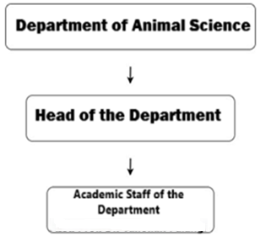
Figure 2. Organizational Chart of the Program

2.7. Program Coordinator
Program Coordinator:
Dr. Hüseyin ÇELİK
Head of the Department
huseyin.celik@neu.edu.tr

2.8. Program Management and Academic Staff
The Department of Animal Science within the Faculty of Agriculture aims to educate competent, modern, and qualified graduates equipped with the theoretical knowledge and practical skills required in the field of animal production and livestock management. The department contributes to both theoretical and applied education through its academic staff, with expertise in animal breeding, nutrition, livestock economics, animal health and welfare, and sustainable animal production systems. As of 2025, the Department of Animal Science has a total of 2 full-time academic staff members, consisting of 1 Assistant Professor and 1 Dr. Lecturer. The academic staff contributes to the field through undergraduate education, supervision of student projects, and scientific research activities. Faculty members are actively involved in academic collaborations and projects that support sustainable livestock production, professional development, and sector-oriented applications.

3. PROGRAM MISSION AND VISION

3.1. Mission

The Department of Animal Science aims to educate graduates who are committed to ethical values, sustainability principles, and scientific integrity; capable of critical thinking and problem-solving; open to lifelong learning; and equipped with a strong sense of professional and social responsibility in the field of animal production and livestock management.

In this direction, the mission of the department is to provide students with solid scientific, technological, and applied knowledge in animal science; to enable them to effectively and efficiently apply their knowledge and skills in modern production systems; to support their continuous professional development; and to educate individuals who are sensitive to environmental, animal welfare, and socio-economic issues at both national and international levels, thereby contributing to sustainable agricultural development and food security goals.

3.2. Vision
The vision of the Animal Science Program is to become an academic unit that embraces universal scientific and ethical values; produces knowledge in the field of animal science; and effectively transfers this knowledge into education, research, and practical applications. The program aims to contribute to national and international developments by following current scientific and technological advances, actively participating in research activities, and supporting scientific progress through projects, publications, and academic events such as congresses, symposiums, workshops, and seminars. In the long term, the program seeks to enhance the quality and sustainability of animal production systems and to educate graduates who are professionally competent, socially responsible, and committed to continuous learning and development.
4. PROGRAM’S CORE VALUES
Core Values
- Commitment to Scientific and Ethical Principles
- Respect for Animal Welfare
- Environmental Sustainability Awareness
- Social Responsibility
- Critical and Analytical Thinking
- Productivity and Integrity in Scientific Research
- Lifelong Learning and Professional Development
- Contribution to Sustainable Agriculture and Food Security
5. PROGRAM ACTIVITY AREAS

The activity areas of the Animal Science Program are addressed under four main headings: education and training, research and development, professional development and continuing education, and community contribution and service.

1. Education and Training Activity Area

The Animal Science Program is structured to ensure that students acquire professional knowledge, practical skills, and ethical values in line with current scientific developments and the needs of the livestock and agricultural sectors. The curriculum is designed with a balanced integration of theoretical foundations and applied learning, covering core areas such as animal breeding, nutrition, animal health and welfare, livestock economics, and sustainable production systems. Student-centered teaching approaches, technology-supported applications, laboratory practices, field-based learning activities are actively employed. Assessment and evaluation processes are conducted using outcome-oriented and process-based methods, including examinations, practical applications, project work, and performance evaluations. Academic advising and guidance services are provided to support students’ academic progress, career planning, and personal development.

2. Research and Development Activity Area

Research and development activities within the Animal Science Program aim to strengthen scientific thinking, innovation, and problem-solving skills among students and faculty members. Scientific research and projects focusing on animal production, sustainability, animal welfare, and efficiency in livestock systems are encouraged and supported. Faculty members and students participate in research activities, academic publications, and applied projects that contribute to the advancement of animal science and agricultural sustainability. These research efforts enhance students’ analytical and research competencies, support evidence-based decision-making, and contribute to improving the quality and relevance of education within the program.

3. Professional Development and Continuing Education Activity Area

Professional development and continuing education activities in the Animal Science Program focus on continuously improving the knowledge, skills, and competencies of both students and academic staff. These activities include participation in seminars, workshops, training programs, and academic events related to modern livestock management, sustainable agriculture, animal welfare standards, and technological innovations in animal production. Such activities support students’ readiness for professional life, help them follow sectoral developments, and strengthen their capacity for lifelong learning. Faculty members are encouraged to engage in academic research, professional networking, and continuous self-development, thereby contributing to the academic quality and sustainability of the program.

4. Community Contribution and Service Activity Area

The Animal Science Program places importance on community contribution and service activities that strengthen the link between academia and society. Faculty members and students participate in activities such as farmer training programs, awareness-raising initiatives on animal welfare and environmental sustainability, extension services, and sector-oriented consultancy practices. These activities contribute to students’ professional and social responsibility awareness, enable the transfer of scientific knowledge to society, and support sustainable agricultural development. Through community engagement, students gain practical experience while contributing to the improvement of livestock practices and rural development.

6. PROGRAM PURPOSES AND OBJECTIVES

6.1. Program Purpose

The purpose of the Animal Science program is to educate qualified Agricultural Engineers and to conduct research in key areas related to food-producing animals. These areas include animal production, management and welfare, nutrition and feeding strategies, enhancement of economically important traits, and the efficient and sustainable utilization of animal resources.

6.2. Writing Objectives
A) Purposes and Objectives Covering the Education Area
Purpose 1: To educate qualified graduates equipped with professional knowledge and skills in animal science.
Objective 1.1: To provide fundamental and advanced theoretical knowledge in animal production.
Objective 1.2: To develop professional skills through applied and practice-based training.
Objective 1.3: To promote awareness of ethics, animal welfare, and sustainability.
Purpose 2: To establish a continuously updated educational program aimed at improving educational quality.
Objective 2.1: To update course contents in line with scientific and technological developments.
Objective 2.2: To apply student-centered and practice-oriented teaching methods.
Objective 2.3: To design assessment and evaluation tools aligned with learning outcomes.
B) Purposes and Objectives Covering the Research Area
Purpose 1: To develop students’ scientific research knowledge and skills.
Objective 1.1: To provide basic knowledge of research methods and techniques.
Objective 1.2: To develop skills in data collection, analysis, and interpretation.
Objective 1.3: To improve academic writing and reporting competencies.
Purpose 2: To contribute to scientific knowledge in the field of animal science.
Objective 2.1: To encourage student participation in research projects.
Objective 2.2: To conduct scientific studies on sustainable livestock production and animal welfare.
C) Purposes and Objectives Covering Contribution to Society and Educational Services
Purpose 1: To educate animal science graduates with a strong sense of social responsibility.
Objective 1.1: To raise awareness of animal welfare and environmental sustainability.
Objective 1.2: To organize informative activities for farmers and sector stakeholders.
Objective 1.3: To provide applied contributions to society in the field of agriculture and livestock production.
7. PROGRAM QUALIFICATIONS
7.1. Program Qualifications
Knowledge – Theoretical and Factual Learning Outcomes
- PY1. Has theoretical and practical knowledge in animal breeding, feeds and animal nutrition, biometrics, and genetics, which constitute the discipline of Animal Science.
- PY2. Evaluates recent developments and practices in animal science and develops projects and solution proposals for problems encountered in animal production.
Skills – Cognitive and Practical Learning Outcomes
- PY3. Uses infrastructure and laboratory facilities required for solving problems in the livestock sector in accordance with contemporary requirements.
- PY4. Identifies problems in animal production and effectively presents developed solutions using written, oral, and visual tools.
- PY5. Uses computer software, hardware, and information technologies required in animal science and adapts them to professional practices.
Competencies – Learning Outcomes for Autonomy and Responsibility
- PY6. Takes part in projects conducted at national and international levels and presents the outcomes of these projects using scientific methods.
- PY7. Actively participates and assumes responsibility in multidisciplinary fields and projects.
Competencies – Learning Competence Learning Outcomes
- PY8. Transfers scientific knowledge obtained through research and technology transfer to education and society.
Competencies – Communication and Social Competence Learning Outcomes
- PY9. Uses at least one foreign language to communicate professionally and to access international sources.
Competencies – Field-Specific Competence Learning Outcomes
- PY10. Acts in accordance with scientific and professional ethics and performs professional duties with an awareness of authority and responsibility.
7.2. The Relationship between Program Qualifications and the Turkish Higher Education Qualifications Framework
The Turkish Higher Education Qualifications Framework (THEQF) is a framework established to ensure the quality assurance of higher education programs in Turkey and to define national-level qualifications. This framework is designed to be compatible with the European Qualifications Framework (EQF). It covers the levels of undergraduate, graduate, and doctoral education.
A) Structure of THEQF
The Turkish Higher Education Qualifications Framework (THEQF) has a structure consisting of four levels for the definition and classification of learning outcomes in educational processes. These four levels are grouped as Associate Degree (Level 5), Bachelor’s Degree (Level 6), Master’s Degree (Level 7), and Doctoral Degree (Level 8). Information about the levels is presented below:
- Associate Degree (Level 5): This level equips students with basic knowledge and skills. It lasts two (2) years.
- Bachelor’s Degree (Level 6): This level provides students with more comprehensive knowledge and skills. These programs may be knowledge-oriented or practice-oriented. It lasts four (4) years.
- Master’s Degree (Level 7): In addition to the bachelor’s level, this level provides more advanced knowledge and skills. It lasts two (2) years.
- Doctoral Degree (Level 8): This is the highest level, where knowledge and skills are developed through original research. It lasts three (3) or four (4) years.
Each level is defined by level descriptors that express specific learning outcomes in terms of knowledge, skills, and competence*. Information regarding these level descriptors is presented below:
* Knowledge: Within the scope of THEQF, “knowledge” is defined as theoretical and/or factual knowledge, which involves the understanding of facts, principles, theories, and practices related to a field of study or work.
* Skills: Within the scope of THEQF, “skills” refer to the ability to apply knowledge and solve problems, including logical, intuitive, and creative thinking abilities, as well as manual skills; and the ability to use methods, ethics, tools, and equipment required in a field of study or work.
* Competence: In TYYÇ, “competence” refers to the ability to use knowledge and skills with responsibility and/or autonomy in a study or work environment; to identify and meet learning needs; and to consider social and ethical responsibilities.
Level descriptors are tools used to define program qualifications (learning outcomes) at the relevant level, to determine the level of qualifications, and to align THEQF with international and national qualification frameworks. In this context, the qualifications (learning outcomes) defined for programs are structured according to the level descriptors mentioned above (Knowledge, Skills, and Competence). Each level is described within the scope of the common learning outcomes associated with its qualifications.
B) The Matrix of the Relationship between Program Qualifications and THEQF
The matrix of program qualifications and THEQF relations for the Depatment of Animal Science is given in the drive link. The program level is Bachelor’s Degree based on Level 6. Click the link below.
Drive Link:
https://drive.google.com/drive/folders/1p3AlbsDfxesx5Pj36e3u4iPlhRMHDf4l
7.3. The Relationship between Courses and Program Qualifications
The association of courses with program qualifications or learning outcomes is important in terms of ensuring the quality assurance and enhancing the academic effectiveness of higher education programs.
This alignment ensures that the knowledge, skills, and competencies expected of students in line with the educational objectives of the program are systematically reflected in the course contents.
A) The Matrix of the Relationship between Courses and Animal Science Program Qualifications
The Matrix of the Relationship between courses and Animal Science Program Qualifications is created. Click the link below:
Drive Link:
https://drive.google.com/drive/folders/1bnoiWC0_uDC-nVGuBaA8rq3KnYt7uukG
8. COURSE LIST
8.1. Distribution Tables of Semester and Elective Courses in the Program
The distribution table of all courses in the Animal Science Program is provided below in the drive link. This table shows the program structure, course organization, the distribution of semester and elective courses in the program, common compulsory courses offered across the University, and information regarding course syllabus.
Drive Link:
https://drive.google.com/drive/folders/1RxRDxS7lxMv_2dxZtMgOsXXUI2uDCsYR
8.2. Common Compulsory Courses Offered University-Wide
In this section, common compulsory courses that must be taught in all undergraduate programs within the university is included. These courses are offered in a standard format across all programs in accordance with the principles set by the Council of Higher Education (YÖK) and constitute one of the fundamental components of university education.
Each academic program carries out its course planning by taking into account the content and learning outcomes of the common compulsory courses listed below. In this context, programs should integrate the relevant courses into their curriculum in accordance with the educational plan and make necessary adaptations in line with the objectives, scope, and content of the courses.
Below, descriptions and core content information of the common compulsory courses applicable to all programs across the university are presented.
Common Course Contents Link:
https://docs.google.com/document/d/1lwVlPmwL_nGJVTn5JcTxdegXtaPN4wgK/edit?usp=sharing&ouid=104243359773687705470&rtpof=true&sd=true
8.3. Course Syllabus
In this section, information regarding the syllabi of all courses included in the program is provided in the drive link below. A course syllabus is an official document that includes the content, objectives, learning outcomes, instructional plan, assessment methods, and other important information related to the course.
Drive Link
https://drive.google.com/drive/folders/1sayjA9swoyKzVq9o2v3n_xqzuNeEATrx
9. PRINCIPLES OF PROGRAM ASSESSMENT AND EVALUATION
9.1. Exam Rules
All information regarding exam rules, variety of assessment tools, etc., will be shared by the Assessment and Evaluation Coordination Office.
9.2. Letter Grade Conversion Table
In this section, the letter grade conversion table is added along with brief information about the presented grades. This section includes the conversion table for letter grades that students receive for each course at the end of the semester, along with brief explanations of the grades. Students’ academic performance is evaluated by the instructor based on in-semester work and end-of-semester exam results. Letter grades are expressed with a coefficient value on a 4.00 scale and also correspond approximately to achievement ranges on a 100-point scale. This system is used as the basis for calculating the student’s overall grade point average (GPA).
Table 9. The coefficients of letter grades and their equivalents on a 100-point scale
Score | Letter Grade
  Coefficient
90-100 | AA | 4
85-89 | BA | 3.5
80-84 | BB | 3
75-79 | CB | 2.5
70-74 | CC | 2
60-69 | DC | 1.5
50-59 | DD | 1
49 and below | FF | 0

Additional Grades Provided Beyond the Above Letter Grades:
I–Incomplete, S–Satisfactory, P–Progressing, EX–Exempt, W–Withdrawn, NA–Absent
(I) Grade is assigned by the instructor to students who, due to illness or other valid reasons, are successful during the term but have not completed the requirements of the course. A student receiving an (I) grade must complete the missing requirements and obtain a grade within 15 days from the date the grades are submitted to the Student Affairs Office. Otherwise, the (I) grade automatically converts to (FF). However, in cases of prolonged illness or similar situations, the duration of the (I) grade may be extended until the beginning of the next registration term with the recommendation of the Department Chair and the approval of the Faculty Administrative Board.
(S) Grade is given to students who pass courses that are not included in the grade point average. The (S) grade is also given for courses previously taken and recognized as equivalent by the Faculty Administrative Board to students transferring from another university or re-enrolling via entrance exam. Students transferring from outside who are required to retake any course according to regulations cannot receive an (S) grade. The (S) grade is not included in GPA calculations.
(P) Grade is given to students who are continuing courses that are not included in GPA calculations.
(U) Grade is given to students who fail courses that are not included in GPA calculations.
(EX) Grade is given to students exempted from certain courses based on a departmental exemption exam as determined by the Senate. The (EX) grade is not included in GPA calculations but is shown on the transcript.
(W) Grade is used for a course withdrawn after the normal add/drop period within the first ten weeks of the term with the recommendation of the advisor and the permission of the instructor. The following rules are applied. (a) Students cannot withdraw from courses in the first two semesters of their undergraduate program. (b) Students cannot withdraw from a course they are required to retake, previously received a (W) grade, or is not included in GPA. Withdrawal is not allowed if the student’s course load falls below 2/3 of the normal load. A student may withdraw from a maximum of one course per term and up to six courses throughout their undergraduate education with advisor recommendation and instructor approval.
(NA) Grade is given to students who, despite being enrolled, do not attend the course.
Table 10: Additional grades provided
I | Incomplete
S | Satisfactory Completion
U | Unsatisfactory
P | Successful Progress
NP | Not Successful Progress
EX | Exempt
NI | Not included
W | Withdrawal
NA | Never Attended
Example Course Syllabus is provided in the link:
Click here to access the example.
https://docs.google.com/spreadsheets/d/1hQPH9qx1o4wIy_c1pWQgd9SMP5RC8sAl/edit?usp=sharing&ouid=104243359773687705470&rtpof=true&sd=true
* Blank Course Syllabus Template is provided in the link:
https://docs.google.com/spreadsheets/d/1YIQ2KHazC2BPSrMXKLQIX7o33CI0bz8P/edit?usp=sharing&ouid=104243359773687705470&rtpof=true&sd=true

10. STUDENT ADMISSION AND REGISTRATION REQUIREMENTS
This section is prepared in accordance with the Near East University Student Admission and Registration Regulations.
At Near East University, education is provided at associate, undergraduate, and graduate levels. The language of instruction is Turkish, and English or other languages may be used when necessary. Examination and evaluation principles are regulated by separate regulations. Student admissions are conducted through the Student Affairs Office within the framework of rules determined by the Senate. Admission to preparatory, associate, and undergraduate programs is carried out either through special exams or without exams for foreign students. Conditions for graduate programs and transfer students are specified in the relevant regulations. Special students may only enroll in certain courses and cannot receive a diploma. Admission and registration conditions for foreign students who are not citizens of the TRNC or Turkey are conducted in accordance with the regulations titled “Admission and Registration Conditions for Foreign Students Who Are Not Citizens of the Turkish Republic of Northern Cyprus or the Republic of Turkey to Higher Education Institutions,” under Articles 65/2005, 21/2008, 40/2009, and 23/2007 of YÖDAK Law No. 11. If deemed necessary, prospective students may be admitted to a one-year scientific preparatory program. Registration is completed when the required documents and tuition fees are submitted within the specified dates. Students are required to renew their registrations every semester. The proficiency level of English preparatory class students is determined by exams, and this education lasts a maximum of two years. Associate, undergraduate, and graduate programs are conducted according to their respective regulations. Students may also take courses for teaching certification. Diplomas for associate, undergraduate, and graduate programs are awarded to those who successfully complete their studies. The issuance of diplomas and provisional graduation certificates is determined by the Senate. Students' grades are officially recorded, and certified documents are provided upon request. No tuition refunds are given to students who voluntarily withdraw or cancel their registration. Students may take leave for health, military service, financial reasons, or educational purposes, and this period is not counted toward the duration of their studies. Students returning from leave must renew their registration to continue their education. Students are guided by their academic advisors. Mandatory internships, disciplinary procedures, scholarships, and health services are regulated according to relevant regulations.
Registration procedures for the Near East University Animal Science Program are carried out in accordance with the university’s general regulations and the provisions of the Higher Education Council (YÖK) and the Higher Education Supervisory and Accreditation Board (YÖDAK). The language of instruction in the program is English. English proficiency is assessed through a compulsory preparatory class, which may last up to two years.
Candidates wishing to enroll in the program must apply based on the results of the Higher Education Institutions Exam (YKS) and be placed by ÖSYM. Registration procedures are conducted through the Student Affairs Office, and the submission of required documents and payment of relevant fees during registration are mandatory. Registration is only completed when all these conditions are fully met. Students must renew their registration at the beginning of each academic term. Students who do not renew their registration lose the right to attend courses and take exams for that term. Foreign students may be admitted to the program without an exam or through a special exam organized by the university. This process is carried out in accordance with relevant legislation and Senate decisions. Individuals with special student status may only take certain courses; they are not considered enrolled in the program and are not entitled to a diploma. Students who successfully complete the program and fulfill all obligations are awarded a bachelor's degree. Students' grade records are securely stored digitally; upon request, these documents can be provided as certified copies to the student or authorized institutions. No tuition refunds are given to students who cancel their registration. Leaves of absence for health, military service, financial reasons, or educational purposes are not counted toward the official duration of study. Such cases are evaluated and decided upon by the relevant committees. Each student is assigned an academic advisor upon registration. Students should maintain regular communication with their academic advisors throughout their education and must obtain advisor approval for course selection, internships, graduation, and similar matters. All processes such as mandatory internships, disciplinary procedures, scholarship opportunities, and health services are conducted in accordance with the current regulations, directives, and Senate decisions of Near East University.

11. Horizontal and Vertical Transfer Opportunities
In this section, the procedures and requirements related to horizontal and vertical transfer processes are explained.
11.1. Horizontal Transfer Opportunities
In horizontal transfers, students applying for transfers within the institution, between institutions, or from abroad should be informed about the important points they need to consider. Horizontal transfers can be made based on ÖSYM scores or grade point averages.

This section outlines the procedures and principles to be followed for horizontal transfer applications to the Classroom Teaching Department at Near East University. All horizontal transfer processes are conducted within the framework of the Near East University Horizontal Transfer and Credit Transfer Directive.
Students applying for horizontal transfer must:
- Have no disciplinary penalties,
- Have a minimum cumulative grade point average of 2.00/4.00 or 60/100,
- Have successfully completed a sufficient number of courses compatible with the curriculum of the program they wish to transfer into.
For transfers based on the centralized placement score, students must meet the minimum score requirement of the program they wish to transfer to for the year of application.
Applications must be submitted within the dates announced by the university, and all required documents must be delivered completely to the relevant academic unit. Applications are evaluated according to students' academic success and available quotas.
Decisions regarding:
- Course exemptions,
- Class equivalencies,
are made by the Faculty Executive Board based on the opinion of the Department Chair. During the evaluation process, particular attention is given to the alignment of pedagogical formation and teacher professional knowledge courses.
Course equivalency is based on the compatibility of the content of courses previously taken by the student at their former higher education institution with those of the program they intend to transfer into.
Applications for horizontal transfer due to special circumstances (e.g., war, natural disasters, health issues, etc.) are evaluated separately according to relevant legislation. In such cases, students may be required to submit additional documentation.

11.2. VERTICAL TRANSFER OPPORTUNITIES
This section outlines the procedures and principles to be followed for vertical transfer applications to the Near East University Department of Animal Science. Students applying for vertical transfer are required to participate in the Vertical Transfer Exam (DGS) administered by the Assessment, Selection and Placement Center (ÖSYM). Preferences are made based on the exam scores, and student placements are carried out by ÖSYM accordingly.
12. RECOGNITION AND CREDIT TRANSFER OF PREVIOUS LEARNING
This section should include information regarding the exemption and adaptation processes at Near East University for courses that students have previously completed and passed, based on the compatibility of course content and credits. The application period, required documents, and evaluation procedures must be clearly specified. Information on how exemptions are recorded in the student’s transcript and their impact on the cumulative grade point average are also provided.
Students enrolled in the Near East University Animal Science Program may request exemption for courses they have successfully completed at previous higher education institutions until the end of the second week of the semester in which the course registration is made. Applications must be submitted in writing to the relevant academic unit and must include approved course descriptions and an official transcript. For courses taken at foreign higher education institutions, the equivalency of these courses must be approved by the Higher Education Council (YÖK) for exemption requests to be accepted. No course exemption is granted between students simultaneously registered in both an associate degree and a bachelor's degree program. Exemption requests are evaluated by the relevant departmental committee, considering the course content, credits, and the student’s success status. Approved courses are recorded on the student’s transcript with the letter grade and included in the cumulative GPA. Exemptions are not granted for failed courses. Exemptions can be granted without credit equivalency for common compulsory courses such as Atatürk’s Principles and History of Revolution, Turkish Language, and Foreign Language. Students may only take the exemption exam for these courses once. If the total ECTS credits of exempted courses exceed 70% of the total ECTS credits of the semester in which the student is registered, the student is placed into the next grade level. However, students who are placed into a higher class cannot take upper-level courses during the first academic year following this placement. Objections to exemption and placement decisions can be submitted within two weeks from the date the results are notified to the student. In cases of horizontal and vertical transfers, course exemption requests are evaluated by the faculty or school board based on the opinion of the departmental committee. For exemption from the foreign language preparatory class, a certain level of language proficiency must be demonstrated through exam results accepted by the university.
13. INTERNATIONAL PROGRAMS AND EXCHANGE OPPORTUNITIES
This section includes general information about “International Programs and Exchange Opportunities,” such as an overview of the programs, participation requirements, exchange and internship opportunities, collaborations and networks, summer programs, support services, as well as the benefits and gains.
Near East University (NEU) offers its students international exchange and internship opportunities, particularly through the Europe-centered Erasmus+ Program, which provides study and internship options. Through this program, students and academics are given the chance to study and intern abroad in European Union member countries. Students wishing to participate in the Erasmus+ Program must have completed at least their first year, demonstrate a certain level of academic achievement, and provide proof of foreign language proficiency required by the relevant program.
In addition, NEU conducts exchange activities through various international student associations in different fields. These associations include:
- IFMSA (Medicine)
- IADS (Dentistry)
- IPSF (Pharmacy)
- IVSA (Veterinary Medicine)
Within these programs, research and clinical internship exchange opportunities are offered to students. During the summer terms, practical training sessions, joint research projects, and cultural activities are organized in collaboration with these associations, involving students from different countries.
Thanks to NEU’s active partnerships with 114 universities from 44 countries, students have opportunities to study and intern abroad while also learning in an intercultural environment on the campus in the Turkish Republic of Northern Cyprus (TRNC). NEU maintains reciprocal collaborations with numerous higher education institutions across Europe, Asia, America, and Africa. Students can study for a semester or full academic year, intern, or participate in international research projects at these universities.
To provide global experience, the university does not limit itself to Erasmus+ but also conducts student exchange activities under the Mevlana and Farabi programs. The Mevlana Program particularly offers reciprocal exchange opportunities with universities in Turkey, while the Farabi Program supports student exchanges among domestic universities. Through these programs, students have the chance to enhance their academic knowledge and gain cultural insights by experiencing diverse cultures.
Throughout the entire process, the NEU International Office provides comprehensive support starting from the application stage, including advisory services, document and application handling, accommodation, and visa matters. Students are informed and guided by expert staff at every step of the exchange process.
14. ACCREDITATION AND QUALITY ASSURANCE OF THE PROGRAM
In line with the university's quality policy, programs are structured within the framework of a sustainable improvement approach. In this context, the program's quality policy, accreditation process, quality of education, research and development activities, and continuous improvement process are addressed in this section.
14.1. Quality Policy
Faculty of Agriculture aims to serve our country and humanity by creating a contemporary learning and progress environment by contributing to the development of new knowledge, technology and products, especially in the agricultural field, within the framework of sustainability and ethical principles. In this context, our faculty was established with the aim of raising landscape architects, food engineers and zootecnicians who are innovative, high-conscious and capable of working interdisciplinary.

14.2. Accreditation Process of the Program
All our programmes are still in the accreditation process.

14.3. Quality of Education
The Near East University Animal Science Undergraduate Program provides a high-quality education through a modern and interdisciplinary curriculum that integrates strong theoretical foundations with extensive practical training in animal production, breeding, nutrition, and management. The program is delivered by an experienced academic staff with both scientific and applied expertise, employing contemporary teaching methods and up-to-date technologies relevant to livestock production systems. Academic standards are aligned with national and international benchmarks, ensuring that graduates acquire the knowledge and skills required to meet the needs of the modern animal production sector. Continuous curriculum development, field-based training opportunities, and collaborations with industry stakeholders support students’ professional development, while the program’s emphasis on critical thinking, sustainability, animal welfare, and ethical responsibility prepares graduates to become competent, innovative, and responsible animal science professionals.
14.4. Research and Development Activities
The Near East University Animal Science Undergraduate Program promotes a strong research and development culture by actively engaging students in projects that address key regional and global challenges in animal production and sustainability. Under the guidance of academic staff, students participate in applied research on topics such as livestock production systems, animal nutrition and feeding strategies, breeding and genetics, animal welfare, sustainable resource use, and rural development in the Eastern Mediterranean context. This research-oriented learning approach is supported by modern laboratories, experimental farms, and data analysis facilities, enabling students to translate theoretical knowledge into practical applications and evidence-based solutions. Through involvement in university-led research projects, national scientific meetings, and international conferences, students contribute to the advancement of animal science while developing strong analytical, problem-solving, and research skills that prepare them for graduate studies or innovation-focused professional careers.
14.5. Continuous Improvement Process
The Near East University Animal Science Undergraduate Program is supported by a structured and systematic continuous improvement process that ensures the curriculum remains current and responsive to developments in animal production and related sciences. This cyclical process incorporates regular feedback from key stakeholders, including students, graduates, and employers, as well as evaluations from advisory boards comprising academic and industry representatives. Collected feedback is carefully reviewed by the faculty to identify strengths and areas for improvement, leading to concrete actions such as updating course content in line with advances in animal breeding, nutrition, welfare, and sustainable livestock systems, introducing new elective courses, and refining teaching and assessment methods. Through continuous monitoring, evaluation, and adaptation, the program maintains high academic standards and effectively prepares graduates to meet the evolving needs of the animal science profession and related sectors
15. GRADUATION REQUIREMENTS AND AWARDED DEGREE
15.1. Graduation Requirements
To graduate from the Near East University Animal Science Undergraduate Program, a student must complete a total of 240 ECTS credits, including compulsory, common compulsory, and elective courses within the curriculum. Additionally, the student’s cumulative (overall) academic grade point average must be at least 2.00. The practicum and internship processes must be fully completed. When all these academic and administrative requirements are met, the student becomes eligible to receive the Landscape Architecture Bachelor's degree diploma.
15.2. Awarded Degree
Students who successfully complete the Near East University Animal Science Undergraduate Program are awarded a bachelor's degree in Animal Science. Graduates are granted the title of 'Zootechnicians.'
16. DIPLOMA SUPPLEMENT
The Diploma Supplement of the Near East University Animal Science Undergraduate Program is given in the drive link below.
Drive Link:
https://drive.google.com/drive/folders/1VIZV-kuklsPa47nJgOb-XiNRGJTQd80E
17. EMPLOYMENT OPPORTUNITIES FOR GRADUATES AND ACCESS TO GRADUATE PROGRAMS
The first heading of this section should cover "Employment Opportunities for Graduates," while the second heading should address "Access to Graduate Programs."
17.1. Employment Opportunities for Graduates
Graduates of the Near East University Animal Science Undergraduate Program are well prepared to enter a broad and evolving employment market both in Cyprus and internationally. They are qualified to work in livestock production enterprises, animal breeding and feeding operations, poultry and dairy farms, feed and animal health industries, and agribusiness companies. Graduates may also pursue careers in public institutions, agricultural ministries, research institutes, cooperatives, and extension services, where they contribute to sustainable animal production, food security, and rural development. Employment opportunities further extend to private consulting, farm management, quality control, and biosecurity-related positions within the livestock sector. In addition, the program provides a strong academic foundation for graduates who wish to continue with postgraduate studies or research-oriented careers, as well as for those aiming to establish their own livestock enterprises or advisory services, supporting a versatile and resilient professional pathway.
17.2. Access to Graduate Programs
Graduates of the Near East University Animal Science Undergraduate Program acquire a strong academic foundation that enables them to apply successfully to a wide range of competitive graduate programs at other universities, both domestically and internationally. The curriculum, which integrates animal breeding, nutrition, genetics, physiology, and sustainable livestock production, equips students with the theoretical knowledge and analytical skills required for postgraduate studies in fields such as animal science, livestock production, animal nutrition, genetics, veterinary-related sciences, and agricultural sciences. Although a master’s program in Animal Science is not yet offered at Near East University, the program’s alignment with international standards and its English-language instruction facilitate graduates’ admission to postgraduate programs in Türkiye, Europe, and other international destinations. This background allows graduates to further specialize, pursue research-oriented careers, and enhance their professional and academic qualifications at recognized institutions worldwide.
18. ADDITIONAL INFORMATION
Difference from Similar Programs
The Near East University Animal Science Undergraduate Program distinguishes itself through its strong integration of theoretical foundations with applied livestock production practices, focusing on sustainable animal production systems suited to Mediterranean and semi-arid regions. The program is delivered in English within a multicultural academic environment and emphasizes animal breeding, nutrition, genetics, welfare, and farm management, setting it apart from more narrowly specialized or theory-oriented programs.
Opportunities Offered
The program provides graduates with diverse career opportunities in livestock production enterprises, poultry and dairy farms, feed and animal health industries, agribusiness companies, cooperatives, and public institutions. Graduates are also well positioned to pursue postgraduate studies at national and international universities, supported by the program’s alignment with international academic standards and its English-medium instruction.
Applied Training
Applied training is a core component of the Animal Science program. Students gain hands-on experience through laboratory practices, field studies, farm visits, and internships in animal production enterprises. Practical training in areas such as feeding, breeding, housing, herd management, and biosecurity ensures that graduates develop not only theoretical knowledge but also industry-relevant technical and problem-solving skills.
Success Stories
Graduates of the program have successfully pursued careers in livestock enterprises, feed and breeding companies, agricultural consulting, and public agricultural institutions, while others have continued their education at postgraduate level in Türkiye and abroad. These outcomes reflect the program’s effectiveness in preparing adaptable and competent professionals for the animal production sector.
Additional Activities
In addition to formal coursework, students enhance their learning through technical field trips, seminars, workshops, and participation in student clubs related to agriculture and animal production. These activities promote professional development, sectoral awareness, and engagement with current challenges in animal science and sustainable livestock systems.

